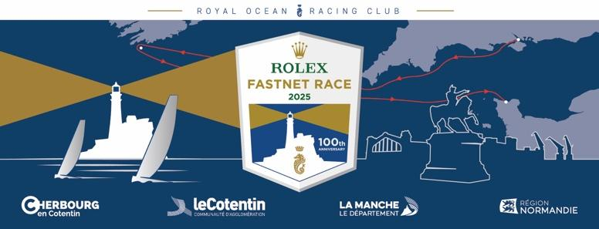

**INTERNATIONAL STORY LEADS**

**2025 ROLEX FASTNET RACE** *(as @180625)*

Notes on just a few of the boats in the record-breaking fleet taking part in this year’s race.

**CONTENTS:**

Page 1 Australia

Page 2 Austria

Page 4 Belgium

Page 5 France

Page 15 Germany

Page 18 Hong Kong

Page 20 Italy, Malta

Page 22 Netherlands

Page 25 Norway

Page 27 Spain, Sweden

Page 28 Switzerland

Page 29 Turkey

Page 29 USA

We have stories and background information on teams from many more countries, so please just let us know how we can help. If you want interviews or contact with competitors from your country/region, please email: [press@rorc.org](mailto:press@rorc.org) and we will be happy to help.

**AUSTRALIA**

**60-year-old legendary offshore winner returns**

*Kialoa II, S&S 73’ yawl, Patrick and Keith Broughton*

Sydney, New South Wales – IRC1

Yacht clubs: RORC, CYCA, RTYC

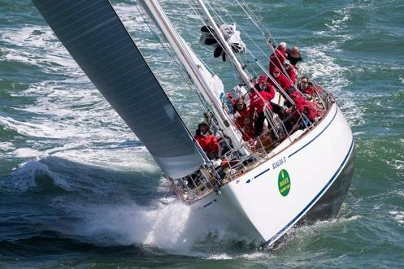

Looking forward to celebrating this special centenary Rolex Fastnet Race, Kialoa II will be returning for a third time. Considered one of the first ‘maxi’ yachts, Kialoa II was designed for Jim Kilroy by Sparkman and Stephens

in 1963 and constructed out of aluminium, originally as a sloop (now a yawl).

After an early career winning most of the maxi ocean races of the day (including the 1965 Transpac and 1971 Sydney Hobart Race, as well as a second place on the water in the 1969 Fastnet Race), she was donated to the US Coast Guard before being sold on and refitted, until brothers Patrick and Keith Broughton found her in 2016. They committed to sailing the yacht as in her heyday, in the offshore races that made her famous. In 2017, that meant entering the Rolex Fastnet Race where they finished 37th in class. 2023, In 2023, they bettered that result to finish 12th in their class.

Brothers Patrick and Keith have a joint history of sailing and love of the sea. British Keith worked as a mine clearance diver in the Royal Navy as well as navigating most of the world’s seas and oceans, while Australia-based Patrick has 13 Sydney-Hobarts under his belt. Overall, the crew are ocean racing veterans, having more than 200 Sydney-Hobart Races between them.

Patrick commented: “The Rolex Fastnet is one of the great ocean races. Highlights for us are exiting the Needles, Land's End, rounding the Rock and the Alderney Race. The tidal gates make it a complex navigational task, but finishing in Cherbourg is an absolute joy, great facilities, excellent reception, fabulous wine and food.”

**www.kialoa2.com.au**

**Facebook: Kialoa II**

**Contact: Melinda Broughton -** [**melinda@kialoa2.com.au**](mailto:melinda@kialoa2.com.au)

**Onboard reporter: Patrick Broughton -** [**paddy@kialoa2.com.au**](mailto:paddy@kialoa2.com.au)

**Australian family crew takes on Fastnet aboard Swan 53***Bedouin, Nautor Swan53, Linda Goddard* Sydney, Australia - IRC 1   
Yacht clubs: Cruising Yacht Club of Australia & Vaucluse Yacht Club

Bedouin is a 2012 German Frers-designed Swan 53, skippered by Australian sailor Linda Goddard. For the 2025 Rolex Fastnet Race, she’s not just leading a racing crew - she’s leading her family. Sailing alongside her four children, aged 15 to 23, as well as an international mix of close friends and experienced racers, Linda is taking on the race as both skipper and mother.

Their goals for the race are clear: to complete it safely, have as much fun as possible, and remain competitive. But for Linda, it’s about more than results. “I expect to be pushed mentally, physically and spiritually,” she says. “To share an unforgettable adventure with my awesome Bedouin crew - and to have no shortage of stories once we cross the finish line.”

She’s especially looking forward to watching her children grow through the experience. “There’s something very meaningful about sailing with them not just across the ocean, but through moments that test their endurance, build their resilience, and bring us out stronger together.”

The team includes co-skipper Guigelmo Giordano (Italy), navigator Alice Parker (Australia), and a broad mix of crew hailing from Sydney, London, Naples, Majorca, and Genoa. Roles range from helm to foredeck, trimmer to tactician. The Goddard Gill siblings - Indy, Leila, Ella, and Julius - each bring their own talents to the team, with Indy currently working as a charter pilot in the Northern Territory, Leila studying commerce at Sydney Uni, Ella pursuing Biology and Sustainable Development at St Andrews, and Julius still in school.

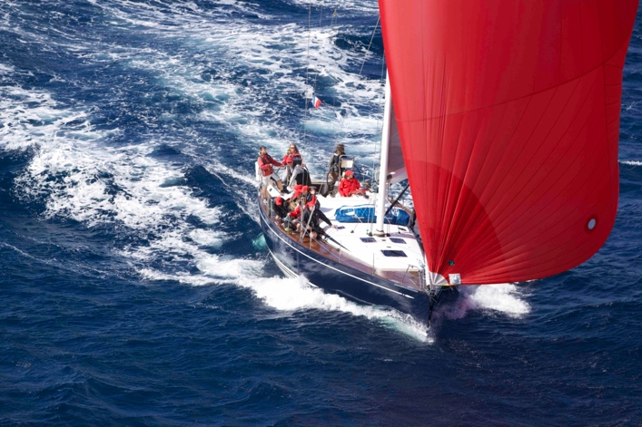“Raw grit, shared laughter, fierce competition, highs and lows that strengthen our bond as a team - those are the moments I’m looking forward to,” Linda adds.

Bedouin was recently featured in the Spirit of Yachting documentary series during the Swan Cup in Sardinia - a testament to the team’s unique blend of family, friendship, and competitive spirit.

Watch their Swan Cup story: <https://www.youtube.com/watch?v=oXZZMHkkpMs>

Social Media: Instagram:   
@teambedouin.racing

Contact:  
Indy Gill - bedouin.swan53@gmail.com, +61 424 101 233  
Linda Goddard - +61 416 663 566

**AUSTRIA**

**Third time for Pro-Am Austrian team**

*Sisi, VO65, Konstantin Kobale – IRCSZ*

Austria

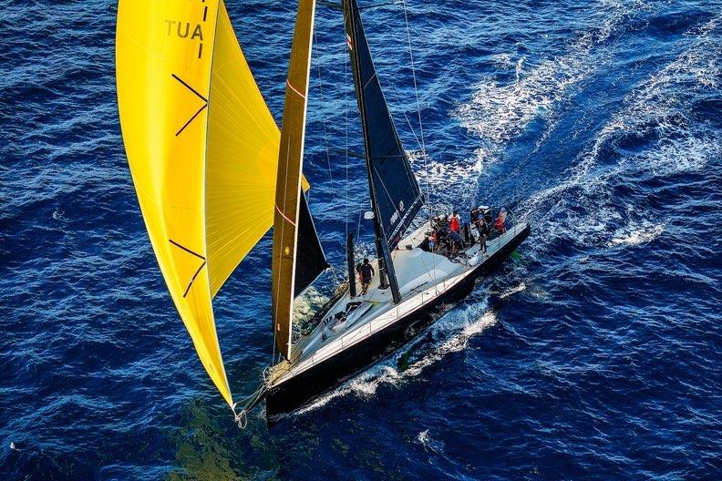

A seasoned 2014 VO65, having competed in 2x Volvo Ocean Race, The Ocean Race Europe 2021 and Sprint Cup 2023, Sisi has been owned by Austrian Ocean Racing since 2019.

CEO and planner, Konstantin Kobale observes: “We competed in the Ocean Race with a professional team. Since then, we attend 10 regatta events a year with pro-am crews. This year we have already raced in the RORC Transat, C600, Heineken, ASW and NYYC Transat…and now the Fastnet!

Konstantin continues: “We are truly passionate about sailing and racing, the charter business is a great opportunity to teach and let people experience the powerful yacht - an experience like no other.

This will be the third Fastnet for the yacht and crew, a true pro/am team, skippered by Konstantin’s younger brother, Oliver Kobale, with 5 professionals and a coach, supported by 14 amateurs.

And they are hoping for “lots of fun and happy faces, to enjoy being part of the history and heritage of the race, and the big fleet after the start in the Solent.

@austrianoceanracing

Ocean-racing.at

PR/Comms onboard:

Media@ocean-racing.at

Office@ocean-racing.at

Contact: Konstantin Kobale - [konstantin@ocean-racing.at](mailto:konstantin@ocean-racing.at)

**Clipper alumni crew come together on Volvo 70 for first campaign***Cockatoo, Volvo 70, Charlie Warhurst*   
Austria - IRC 0  
Yacht clubs: RORC

Cockatoo is a high-performance Volvo 70, originally built for the 2008-09 Volvo Ocean Race. For the 2025 Rolex Fastnet Race, she returns to top-tier offshore racing under the command of skipper Charlie Warhurst, leading a fresh but ambitious crew largely formed from veterans of the Clipper Round the World Race.

This is their first race together since that global adventure, and expectations are high - not just for performance, but for the experience. “We’re looking for a competitive and fun race, aiming to push our boundaries and build on everything we’ve learned,” says Charlie. “The whole atmosphere around Fastnet is electric - from the energy on the start line to the battle out through the Needles.”

The team is a blend of British, European, and South African sailors, united by a shared drive to take on one of sailing’s most iconic offshore challenges. The full crew list includes 21 sailors, representing a wide range of professional backgrounds - from lawyers and doctors to business professionals and even a few rocket engineers.

Though the campaign is still coming together in parts, including finalising their onboard reporter (OBR), the team is planning to document their experience in real-time. “We’ll be sharing updates, photos, and video from onboard during the race and afterwards - we want people to follow along with us,” says Charlie. Updates will appear via Charlie’s personal Instagram and via the OBR’s channels once confirmed.

The team may be relatively new to the boat, but their energy and momentum are already building. With a legendary race yacht beneath them and an enthusiastic crew aboard, Cockatoo is shaping up to be one of the stories to watch.

Social Media:  
Instagram: @charlie.warhurst  
LV Yachting

Contact:  
Charlie Warhurst - charlie@thewarhursts.co.uk  
+44 7875 843859

**Takari brings Austrian teamwork and humour to Fastnet race***Takari, RM1270, Thomas Murlasits*Austrian - IRC 1  
Yacht clubs: Yacht Club Weyregg, Austria

Chartered from Quiberon, France, Takari is a French-built RM1270 that will race under the French flag in the 2025 Rolex Fastnet Race - out of respect for her origins. But on board, it’s an all-Austrian team. All crew members live in or near Vienna, and the campaign proudly represents Austria, with skipper Thomas Murlasits hailing from Yacht Club Weyregg on Attersee.

“It’s a charter boat from France,” Murlasits explains. “As the charter boat is based in Quiberon (France), therefore we start with French Flag on the boat. The whole crew lives in Austria, so we are representing Austria and are still in contact with the most Austrian starters.”

The team is focused on enjoying the journey while meeting the challenge of the course. “Main target for us is to have a good time on sea and to finish in time to enjoy the price giving and the final ceremony,” he says. “Second target is to have a good race without any injuries and not to be the last one in the ranking. We expect rough sea, hard winds and a hard competition.”

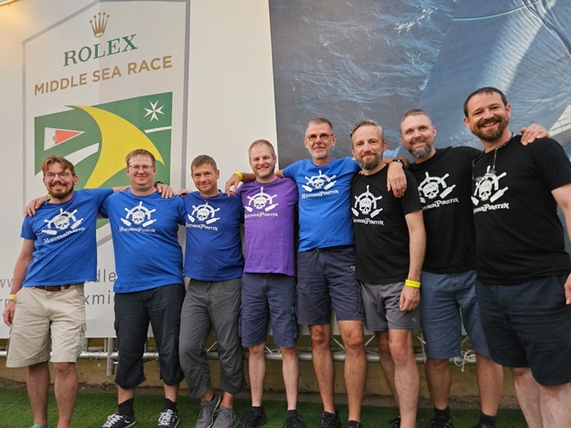As for what they’re most looking forward to? “To be part of the legendary Fastnet race, to see/feel the high level of international sailing performance and of course, to round the famous Fastnet rock.”

Crew members Daniel, Roland, Martin, Oliver, Johannes and Gaetan (the only one with a French passport) work as a rotating unit. “We don't have fixed positions on board - everyone is making everything and we are changing positions every hour. Daniel as co- and me as skipper we have the additional task to make decisions when no other one wants to make them ;-)”

Professionally, the crew describes themselves humorously as: “mostly nerdy IT guys.” But what they lack in traditional sailing CVs, they make up for in cohesion and energy. “The best crew ever - for sailing and to party!”

**BELGIUM**

**Ahoy! The Bonny Ladies of Belgium**

*Anne Bonny, Swan 46 MKII, Sigrid Huyghe/Elke De Witte*

Ostende – IRC2

Yacht Club: RNSYC

Race team, Swanne Bonny, is an all-female, all-Belgian team, aged 24 to 62, aiming to inspire other women in Belgium to undertake sailing adventures ([www.swannebonny.be](http://www.swannebonny.be)).

The team take the name of their boat, Anne Bonny, from a 17th-century pirate who defended her vessel, while the men below deck slept off their drunken stupor.

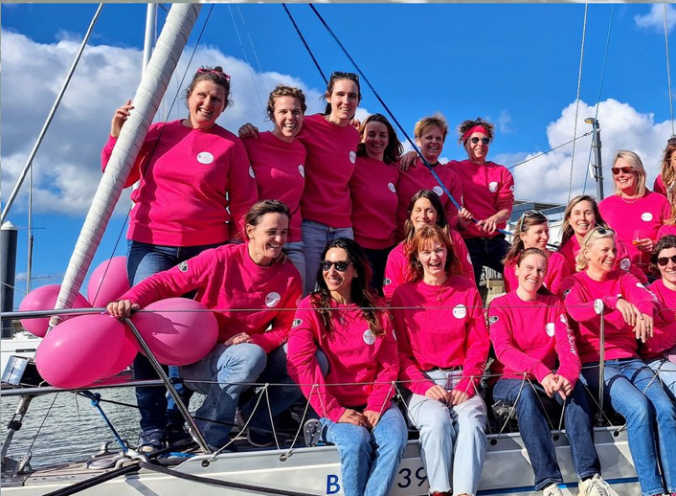

All crew members will be taking part for the first time, and have a variety of skills that should prove useful: medical doctors, engineers, nurse, airline pilot, physiotherapist, HR consultant and transformation coach.

Under the umbrella of VZW Stuurvrouw, a not-for-profit organisation, they have partnered with [www.sailingforthinkpink.be](http://www.sailingforthinkpink.be) to raise funds for breast cancer research, with a cruising event in September.

Skipper Sigrid Huyghe comments: “As with many other races, the female participation rate is still remarkably low... However, the Rolex Fastnet is the most fascinating and challenging race in Europe, and we wanna prove we can do it as well as our male counterparts!

Probably the most challenging is getting well prepared at the start line, ticking all safety boxes...how challenging the rest of the race will be, not sure, but as first timers we are excited for all of it!”

[**www.swannebonny.be**](http://www.swannebonny.be)

**https://www.instagram.com/swanne_bonny/**

**Contact:** [**delphine.leonard@swannebonny.be**](mailto:delphine.leonard@swannebonny.be)

**University friends join Fastnet for the first time**

*Ikigaï, Grand Soleil 43 B&C, KYCN (Benoît Stevens)*

Nieuwpoort – IRC2

Yacht Club:KYCN, the Royal Yacht Club of Nieuwpoort, RORC.

This will be the very first Rolex Fastnet Race for Ikigaï, and her crew, representing KYCN, the Royal Yacht Club of Nieuwpoort.

Skipper Benoit Stevens describes the Grand Soleil 43: “She was built in 2006, and is a classy, high-performance cruiser-racer, with serious offshore pedigree. She’s quick, responsive, and beautifully built. She eats up miles with ease.”

Ikigai has a tight, fixed crew who met at KYCN Nieuwpoort and the University of Louvain Yachting Club. Since then, they have kept sailing and racing together, evolving into a passionate, multigenerational team, still driven by the same love for sailing.

Benoït mentions that the team could not be more excited: “This race has been a dream for a long time. This will be our first one. Our main goal is to experience it fully—respecting the course, the sea, and the tradition. We want to finish proud, tired, and smiling, knowing we met the challenge head-on. If we come away with stories, stronger bonds, and maybe a bit of salt in our souls, then we’ve done what we came for. Nevertheless, our primary aim is to complete the race safely and as a cohesive crew.”

Benoït goes on to say: “Like Eric Tabarly said: "To sail well is not to go fast, it's to go where you need to, when you need to." We are looking for a true human adventure — a mix of seamanship, friendship, and unpredictability. Every mile is a new lesson. We want to keep growing together as a team and push Ikigai to the next level. Obviously, we also want to score, as our team is rather competitive and experienced in racing.

For us, the challenges are maintaining focus through the tactical pressure points: the tidal gates, wind shifts near the coast, and the approach to the Rock. Every small mistake can cost hours, so staying mentally fresh and making good decisions over 695+ miles is the hardest and most crucial part. However, honestly, the most challenging part isn’t just the race itself, I guess — it’s everything that leads up to it. The preparation in the year before has been intense: making sure the boat is technically ready for offshore conditions, reviewing safety protocols, training as a crew, and fine-tuning our roles and communication on board. Offshore racing is demanding, and we’ve put a lot of energy into being not just fast, but safe and solid together.

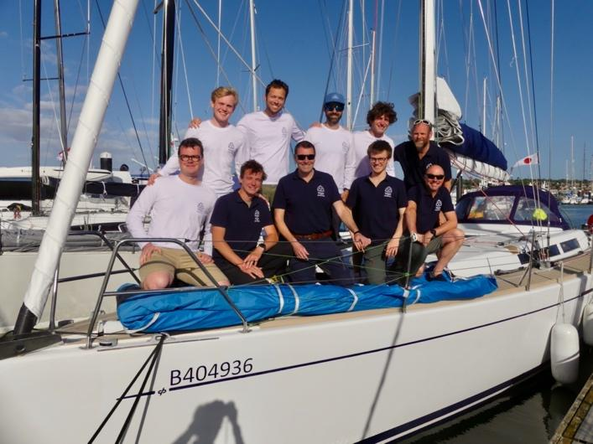

The Rolex Fastnet Race is one of those iconic races you must experience once in your life — it is pure legend. It’s one of those lifetime milestones for any sailor, and we feel incredibly proud to take part. To round the Rock, to sail that course, to face what so many before us have faced—that’s something we’ll carry with us forever. No doubts.

The highlights of the course aren’t just places like the Solent, Bill of Portland, Land's End, the Rock the Casquets or Cherbourg — they’re moments where you reconnect with the world as it once was. Out there, away from screens and noise, you feel how small you are, and how big the sea still is. It’s a reminder of what really matters.”

**Instagram : ikigai_sailing_team**

**Contact: Benoit Stevens - Brussels / Belgium**

[**benoitxstevens@gmail.com**](mailto:benoitxstevens@gmail.com) **+32496578430**

**FRANCE**

**Doublehanded team hope for blue skies and softer weather**

*Blue Skies, JPK 1030, Luc Fourichon,*La Rochelle – IRC3

Yacht Club: Member of "La Team" / La Rochelle, La Rochelle Nautique

Once again, Gérard Quenot and Luc Fourichon will be sailing doublehanded in their 5th Fastnet. After meeting several times at the French Championship for Enterprises – they both used to work in the automotive industry, but in different companies - they decided to join their skills and experience for their first big double-handed challenge, the Transquadra 2011-2012, which they won.

Both co-skippers are also involved as volunteers in important sailing clubs: Luc was President of Les Glénans several years ago, and is still involved there as a volunteer instructor; Gérard was recently elected as the President of La Rochelle Nautique.

They have competed in several previous editions of the Fastnet, with complete crews: 2013, 2015 and 2019, with decent results, being class winners in 2015.

More recently, Gérard won Cap Martinique 2024, double-handed with another co-skipper.

Commenting on the 2023 edition of the race, Luc says: “First of all, like many competitors, we hope that the weather will be a bit softer than 2023. Fortunately, we could perform and finish the race without any damage, but it was not so pleasant. Anyway, I don't know if we are masochistic, but we’ve come back.”

His chosen highlights are: “First of all, getting out of the Solent, and passing the Needles as the different IRC Classes are getting together - it’s a beautiful vision of all those quite different boats together. Then, I would say that the first half of the race is usually the most interesting: playing along English Shore, then deciding when is the right time to switch to "off-shore mode”.

**For the main races, especially for the Rolex Fastnet Race, follow Luc’s YouTube channel: lfourichon**

**Contact: Luc Fourichon - l.fourichon@wanadoo.fr**

**First timer in training for Solitaire du Figaro**

*ALOFI, Monohull Figaro Beneteau 3, Thierry Levayer*

La Rochelle – IRC2

Yacht Club: La Rochelle/CEV (Centre Excellence Voile)

It will be first time round for this French one design class boat, representing La Rochelle and the CEV (Centre Excellence Voile).

After competing in the Solitaire du Figaro (2nd in 2021 and 2022 with Xavier Macaire), she will complete the 2024 and 2025 seasons as ALOFI.

Thierry Levayer, from Nouméa, New Caledonia, is doing the race with a close friend (and very experienced sailor), Philippe Delamare, as a training exercise for the next Solitaire du Figaro. Thierry has racked up lots of dinghy sailing (windsurfing, 49er, WASZP) and 50,000 miles of cruising and racing big boats. He took part in the 2024 season in the Figaro 3, all the races including Solitaire du Figaro (3 stages of 600 miles each solo).

Philippe Delamare, from Lorient, has accrued more than 100,000 miles cruising and is the professional skipper of Nomad IV (100 feet carbon monohull). Winner of the GLOBAL SOLO CHALLENGE 2023-2024 (solo nonstop around the world race). Philippe is building a 130 feet carbon catamaran in Lorient.

**Facebook: Alofi sailing**

**Contact: Thierry Levayer -** [**alofi.sailing@gmail.com**](mailto:alofi.sailing@gmail.com)

**Father and son join friends for first time Fastnet**

*Faiaoahe, Monohull prototype 66', Rémy Gérin*

La Trinité sur Mer – IRC1

Yacht Club: Yacht Club de France

Although this will be Rémy’s first time in the Fastnet, he knows the boat (2006) very well, having sailed her up to The Marquesas Islands, then back round Cape Horn.

“We just want to enjoy the race and be part of the history of offshore racing. The challenge depends on the winds! But getting out the Solent among all that fleet will be huge, as well as rounding the Fastnet for the first time.”

It is a friends and family crew, one of them being Rémy’s son, Oscar. Together, they have completed more than 10 ocean crossings (Atlantic and Pacific) onboard s/y Faiaoahe:Olivia DePous, Thierry Garnier, Yann de Pascau, Stefan Jensen, Oscar Gérin, Rémy Gerin (skipper).

**Contact: Rémy Gérin - rgerin@mediaperf.com**

**Rite of passage for young doublehanded crew**

*Alwena for Pure Ocean, Sun Fast 30 OD, Clara Bayol*

Marseille – IRC3

Yacht Club: Union Nautique Marseillaise (UNM)

Designed by VPLP, Alwena for Pure Ocean is a very recent boat, built in 2024. It was produced to make offshore racing more affordable for a young crew, and set to replace Figaro 3 on the sailing Tour de France. It is part of the Massilia Sailing Academy which promotes offshore race training and the protection of the oceans.

Helmsman, Charles HENON, from Vence (near Nice, France), and crew, Clara BAYOL, from Marseillle (France), are a young doublehanded crew (a salesman and an engineer) who started racing in September 2024, sailing in inshore and offshore races in the Mediterranean Sea (Paprec 600), before moving into the Atlantic and the English Channel. Their goal is to qualify for the Doublehanded Offshore World Championship in Cowes in September 2025.

This is their first Fastnet and the first offshore race together. Charles started with inshore sailing (one National French title), then joined a crew in match racing for 2 seasons (3rd place at the World Championships), before sailing across the Atlantic with a group of friends.

Clara started in inshore sailing in match racing (2 world titles) for 3 years, before joining this offshore project.

The owner of the boat is Ludovic Gérard who will sail the Fastnet Race on another boat (Solenn for Pure Ocean).

Charles and Clara are both ambassadors for the Pure Ocean Foundation. Clara elaborates: “We are proud to represent the Pure Ocean Foundation in this race (www.pure-ocean.org). The foundation’s mission is to support and fund scientific research focused on ocean study and marine ecosystem conservation.”

About their expectations for the race, Charles says: “It is an honour to enter the race as a doublehanded crew and we hope to do the best result possible in our category. We are eager to join the start line, alongside all the other teams and to set course for the iconic Fastnet Rock. Our biggest challenge will probably be the weather routing, especially considering the currents and rocky obstacles along the coast. The race is also known for its harsh conditions in these areas, which could be particularly challenging for both the crew and the boat, if this edition proves to be similar.

It is an honour to enter the Rolex Fastnet Race as a doublehanded crew and we hope to do the best result possible in our category. It’s a legendary race that stands as a rite of passage for any sailor venturing into offshore sailing. Many of my fellow sailors have experienced it as a major milestone in their careers — something clearly reflected in the impressive number of entries for this year’s edition.”

Contact: Clara Bayol - [bayol.clara@gmail.com](mailto:bayol.clara@gmail.com)

Website: massiliasailingacademy.fr  
Instagram : @massilia_sailing_academy  
Facebook : Massilia Sailing Academy  
LinkedIn : Massilia Sailing Academy

**Breton Oceanographer and Sailmaker in first Fastnet**

*Zephyrin, Jeanneau Sunfast 3200, Pierrick Penven*

Brest – IRC4

Yacht Club: Yacht Club de la Rade de Brest

Pierrick Penven from Brest, an oceanographer specialising in ocean modelling and simulation, will be sailing with co-skipper and sailmaker, Fanch Le Guern, in their first offshore race together.

Pierrick has done several solo offshore races with Zephyrin, but this will be his first Fastnet.

The doublehanded crew on Zephyrin (2012) will be looking to “do a nice race, have fun at sea with friends, push the limits of Zephyrin, while trying to keep up with the new designs.”

Pierrick says: “The first challenge has been getting ready, preparing the boat, doing the paper work. And finding a good insurance company.”

“The Rolex Fastnet Race is an excellent format – many boats and very contrasted conditions.”

**Contact: Pierrick Penven -** [Pierrick.penven@ird.fr](mailto:Pierrick.penven@ird.fr)

**Back this year as part of IRC crew**

*MAïGAB, Sunfast 3200, Christian Jacquelin*

Port de La Rochelle – IRC4

Yacht Club: CNLR

Having had to abandon in 2023, Christian Jacquelin and his crew are back, hoping to complete the race this time and enjoy this centenary edition of the legendary race.

“I have personally taken part in the Fastnet race 3 times in a Mini Transat 6.50, and would like to do it again as part of an IRC crew,” says Christian.

His crew are a group of friends who have been sailing together for a few years, “we’re looking forward to some convivial parties before the departure in Cowes. Then we’d like to get out of the Channel in the 1st third.”

**Contact: Christian Jacquelin -** [**christian.jacquelin.cj@gmail.com**](mailto:christian.jacquelin.cj@gmail.com)

**Second time round, with 3rd in class to beat**

*Karavel,* JPK 1080*, Frédéric Nouel*

Trinité sur Mer – IRC3

Yacht Club: Société Nautique de la Trinité sur Mer, YCF,  
RORC

This will be the second Fastnet for Karavel. Built in 2019, she achieved 1st in the ArMen race 2023, 3rd in the Rolex Fastnet Race 2023 and 1st in the French IRC 2 championship Channel - Atlantic 2024

Owner/skipper Frédéric Nouel is from Paris and has 2 doublehanded transatlantic races under his belt. His crew are all Corinthians, experienced sailors helped by “three brilliant men in their twenties. There is an architect, a clever engineer working on racing boats, and the rest of the crew have boring jobs (lawyer etc..)”

Frédéric is a “fresh and new” RORC member who aims to be in the top ten IRC in their class. “We are looking forward to a fantastic race, after 3 marvellous days in Cowes.”

**Contact: Frédéric Nouel - frederic.nouel@gmail.clm**

**Breton doublehanded crew with engineering skills**

*Moïse, JPK 1010, Pierre-Yves Fouché*

Port Le Crouesty – IRC4

Yacht Club: YCCA- Orlabay

Built in 2013, Moïse is based at Port Le Crouesty. This will be the first time round the rock for this French doublehanded team of engineers from Brittany.

Pierre-Yves Fouché has 4 years doublehanded experience, with 1 transatlantic race. He met his co-skipper Lejeu (Rennes) on the Transquadra transatlantic race.

Pierre-Yves comments: “I’m looking forward to competing properly in my first Fastnet race, such a renowned event in the sailing community, with top sailors coming. The 2 first days along English & Cornwall coasts will be a challenge.”

**Contact: py_fouche@yahoo.fr**

**Meaningful memories for 77-year-old owner**

*Maori III, Sun Fast 3200, Davi Vasconcellos*

Le Havre – IRC4

Yacht Club: CNPV (Centre Nautique Paul Vatine)

The Sun Fast 3200 is a 33-foot (10.1 m) racer-cruiser sailboat designed by Daniel Andrieu and built by Jeanneau between 2007 and 2019. Maori herself was built in 2017, and has been based at Le Havre since 2020, racing in many races around the Bay of the Seine.

Maori's owner, Jacques, is 77 years old, and the aim for this year's race is to fulfil a meaningful personal achievement and experience for him, while sharing it with a great crew of friends.

Skipper and navigator, Davi Vasconcellos, now 40, started sailing relatively late, at the age of 30 in Naples. A key highlight of his sailing journey so far was the delivery of a Class40 from Lisbon to Le Havre, which he did alongside the owner of Maori.

Davi describes the crew:“We’re a group of friends who regularly race together—or sometimes against each other—in regattas around Normandy. The crew comes from a variety of professional backgrounds, including engineering, company ownership, physiotherapy, public education administration, and office administration:

Davi – Paris, Skipper and Navigation

Jacques – Le Havre, Owner, mainly Sail Trimming

Nathalie – Le Havre, Helm and Bow-woman

Isabelle – Le Havre, Helm and Pit

Pierre – Le Havre, Helm and Sail Trimming

Of this year’s race, Davi says: “Of course, we also aim to stay competitive and give it our best. We are most looking forward to completing the race and earning a respectable position.

The most challenging part will be maintaining a focused racing mindset and optimal boat configuration over five days, especially with a crew of senior sailors.

What makes the Rolex Fastnet Race so special is the opportunity to compete alongside some of the most professional skippers and advanced boats in the world, and to experience the atmosphere of a truly professional offshore race.”

**Contact: Davi Vasconcellos -** [**davivasconcellos@gmail.com**](mailto:davivasconcellos@gmail.com)

**Dream come true for Skipper Yann Yallu**

*Selenite, A35, Yann Jallu*

La Trinité sur Mer – IRC4

Yacht Club: SNT (Société Nautique de la Trinité-Sur-Mer)

For Breton Yann Yallu from La Trinité sur Mer, the Rolex Fastnet Race is “THE RACE to be in. It is something I have been dreaming about for many years now. This is my first time, so my expectations are very simple: finish the race and learn more about offshore racing.”

Yann started to sail in 1995 in La Rochelle, France. In 1999, he moved to New York City and joined the Manhattan Yacht Club, racing 2 nights a week on a J24 in between the Twin Towers and the Statue of Liberty. These evening races also gave him the opportunity to race in Long Island Sound in between 1999 and 2005. He joined another boat and raced on a J27 on the East Coast of the USA in different regattas. He participated 4 times in Key West Race Week and won it in 2005. He came back to France in 2006 and went back to racing in 2019 after a long break building his business and taking care of his family.

This year, along with his co-skipper Gurvan Jego, he joined the Orlabay training centre to practice doublehanded racing. For this race, there will be a full crew because this is their first time in the Fastnet race. Some of the crew have already participated in the Fastnet before, but not on Selenite.

Yann comments: “I am really looking forward to the start of the race, I think it will be really impressive. I am also looking forward to rounding the Fastnet rock.”

**instagram: breton_sailor**

**Contact: Yann Jallu -** [**yannjallu@gmail.com**](mailto:yannjallu@gmail.com)

**10th Fastnet for Foggy Dew**

*Foggy Dew, JPK 1030, Noël Racine*

Le Havre, Normandy – IRC3

Yacht Club: SNPH YCF

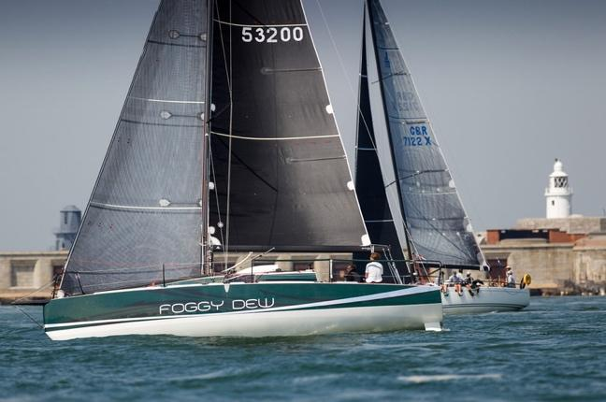

Skipper Noël Racine is a seasoned Fastnet veteran. He and his crew have been racing together for ten years, having taken part in 9 Fastnet races, a Middle Sea Race, and others. There are no professional sailors onboard, but one has experience of the Whitbread and another the experience of AC training in the 90's.

Noël says of his crew: “Three of us are retired, the other one is still working:

Noël Racine, French Le Havre skipper, navigator

Ludovic Sénéchal, Le Havre co-skipper, performer

Benoit Caigneart, La Roche sur Yon, performer

Chloé Lienart, Paris, N°1

**Contact: Noel Racine -** [**racinelh@aol.com**](mailto:racinelh@aol.com)

**“Hôpital Necker, on navigue pour toi…”**

*Inter Invest, Ocean 50, Sebastien Rogues (Owner)/ Matthieu Perraut (Skipper)*

Pornichet

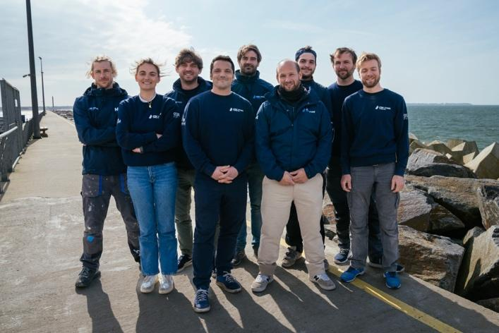

Designed by R. Neyhousser and François Thumerel, and built by renowned composite experts Multiplast in 2022/3, the Inter Invest trimaran is one of the newest and most competitive Ocean 50 multihulls on the circuit. She combines cutting-edge naval architecture with lightweight construction and innovative design to push the boundaries of offshore performance.

The Rolex Fastnet Race marks a thrilling milestone for Inter Invest - not only as a serious contender tobe the first Ocean 50 to cross the finish line**,** but also as an opportunity to embrace the international spiritof the race.

“Our class is mostly French and most of our races are only with French crews, so it's exciting to participate to a more international competition.” says Matthieu Perraut, designated skipper for this race.

Matthieu and Sébastien Rogues form a unique partnership in the Ocean 50 world, under the colours of the Inter Invest Group. For the first time in the class’s history, two skippers are officially co-leading a team of 9 sailing professionals, dividing responsibilities strategically:

**Matthieu Perraut** – Offshore racing  
**Sébastien Rogues** – Inshore racing

Their synergy and complementary strengths - Matthieu’s expertise in Class40 racing and his mastery of weather strategy and Sébastien’s in-depth knowledge of this class and of crewed sailing - define the Inter Invest Sailing Team’s ambition for 2025: to win every race they enter**.**

But it’s not only about competition. Inter Invest races with a cause close to their hearts, in support of Hôpital Necker – Enfants Malades in Paris, the team raises awareness of epilepsy, which affects 0.5% of the population. For 30% of patients, medications are not effective and surgical solutions require advanced diagnostics using high-definition MRI, genetic testing, and neurocognitive evaluations.

This initiative, founded by Sébastien Rogues and neurosurgeon Thomas Blauwblomme, reflects the team's commitment to solidarity, medical advancement, and children's health.

**Matthieu Perraut**

* Grew up sailing in Brittany
* Former architecture student turned ocean racing professional
* Mini Transat 2019 finisher (25th)
* 2nd in the Class40 World Championship (2022) – supported by Inter Invest Group
* 7th in the Transat Jacques Vabre (2023

**Sébastien Rogues**

* Winner, Ocean 50 Series (2024)
* Youngest Transat Jacques Vabre winner (2013, at age 26)
* Over 20 years in competitive offshore sailing, including five seasons of Ocean 50 experience

https://www.inter-invest.fr/sailing-team/equipe

https://www.instagram.com/matthieu_perraut/

https://www.matthieuperraut.com/ (all other social media can be found on the top right hand of the website)

**Contact: François Thumerel**

[**francois@merdhuile.com**](mailto:francois@merdhuile.com)

**PR/Comms: Sarah Pitkowski** [**s.pitkowski@15love.net**](mailto:s.pitkowski@15love.net)

**+33 6 08 26 47 61**

**Birthday goal becomes Fastnet reality for French skipper of KATIU***KATIU, Grand Soleil 50 Performance, Frédéric Gougeon*Port Haliguen, France IRC 1  
Built in 2006 and purchased in spring 2022, *KATIU,* is a Grand Soleil 50 Performance now skippered by Frédéric Gougeon, who bought the boat with two dreams in mind: racing the Rolex Fastnet for his 50th birthday, and one day sailing across the Atlantic with his family. The boat takes its name from an atoll in the Tuamotu Islands in French Polynesia - a long-term goal for Frédéric, inspired by the idea of adventure and self-discovery through sailing.

While he turned 50 in 2023, the boat wasn’t yet ready for competition - so the 2025 edition of the Rolex Fastnet Race is the realisation of that birthday goal, just one year on. Frédéric has raced the Fastnet once before - in 2015 aboard Class40 *Changabang* - but this marks his first time as skipper of his own campaign.

The current crew came together in 2022 during *KATIU*’s delivery passage from Genoa, Italy, to Quiberon in Brittany. Since then, they’ve been preparing steadily for the challenge ahead.

“For us, this race represents a great human adventure,” says Frédéric. “Our aim is to finish somewhere in the middle of the rankings - and to be part of something historic.”

Beyond the result, the crew is motivated by the scale and significance of the event itself. “To take part in this edition of the race is to participate in a historic tradition - and to share in something far bigger than ourselves.”

**Back for another “legendary moment”**

*YESSS ELEC EAU, JPK 1030, Bertrand Fourmond*

Locmiquelic – IRC3

Yacht Club: Club Nautique de Lorient (CNL)

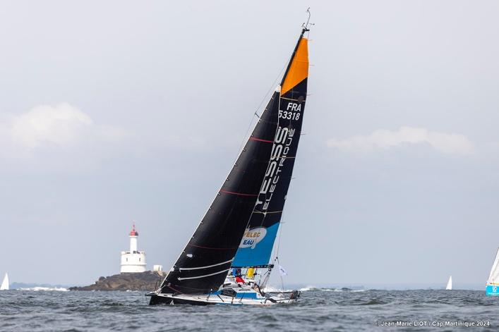

Built in 2021 specifically for IRC offshore racing, skipper Bertrand Fourmond has already covered over 14,000 nautical miles of racing onboard YESSS ELEC EAU. She’s competed in ArMen, 45/5, Rolex Cap Martinique and now, the next Rolex Fastnet.

"I've already completed 4 transatlantic races and crossed the English Channel 4 times, but taking the start of the Rolex remains a truly legendary moment for any sailor." says Bertrand.

Bertrand, a business manager from Sable sur Sarthe, will once more by joined by his 2023 crew member, Éric Tilly, a purchasing manager in a large company from Issy les Moulineaux.

This year’s objective is to finish the race, as they had a problem with the mainsail in 2023. Bertrand says of the Fastnet: “It is a beautiful, very committed race that isn't afraid to face the winds and the ocean. There are many nationalities and a magnificent start. It starts on an island that breathes sailing and is a race that shares its place in France.”

Blog: https://teampoussone.wordpress.com/a

https://www.facebook.com/teampoussone

https://www.instagram.com/skipperbertrand

**Bertrand Fourmond**

[**Bertrand.fourmond@eleceau.fr**](mailto:Bertrand.fourmond@eleceau.fr)

**Comms: Céline Fourmond**

**teampoussone@gmail.com**

**+33627500101**

**Legendary Volvo 60 returns to the Fastnet under French training banner***LIBERTALIA (racing as CHALLENGE OCEAN), Volvo 60, Valdo Dhoyer*Lorient, France - IRC 0  
Yacht clubs: Challenge Ocean, UNCL

*Libertalia* is a 19.50m Volvo 60 racing yacht - originally built for the 2001-2002 Volvo Ocean Race under the name *Djuice Dragons*. Designed for the grueling around-the-world race, she was skippered by Knut Frostad, with Thomas Coville serving as Watch Leader and Jean-Yves Bernot as Navigator. Today, the boat races under the name *CHALLENGE OCEAN*, operated by the French sailing school of the same name, and continues to compete at the highest level in offshore events including the Rolex Fastnet Race, RORC Atlantic Race, and the Tour de Belle-Ile.

Based out of Lorient and affiliated with FFVoile, *Challenge Ocean* offers high-performance racing experiences for ambitious amateur sailors, supervised by a team of four professional crew: skipper, first mates, and navigator. “Our crew members are customers,” says Valdo Dhoyer, “but we approach this event with a competitive spirit and high expectations.”

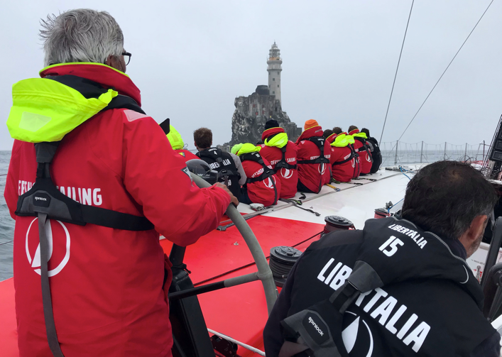The 2025 Fastnet will see *Libertalia* line up in the IRC 0 class - one of the toughest divisions, filled with large, high-spec professional teams. “We want to do our best in that fleet,” Dhoyer adds. “And most of all, give our sailors an exceptional experience they’ll never forget.”

The team is qualifying for the race via delivery passage from Lorient to Cowes, and will be available for interviews two days before the start. Final crew list and backgrounds will be confirmed on Sail Race HQ in June.

**Social Media:**Website: <https://www.challengeocean.com/>Facebook: /challengeocean  
Instagram: @challengeocean  
LinkedIn: Challenge Ocean

**Contact:**Valdo Dhoyer - valdo@challengeocean.com  
Phone: +33 6 09 31 28 35

**Five laps of the globe behind them, Banque Populaire targets Fastnet victory**  
*MAXI BANQUE POPULAIRE XI, Maxi Trimaran, Delphine Gallais*Lorient, France - Classe Ultim   
Yacht clubs: Team Banque Populaire

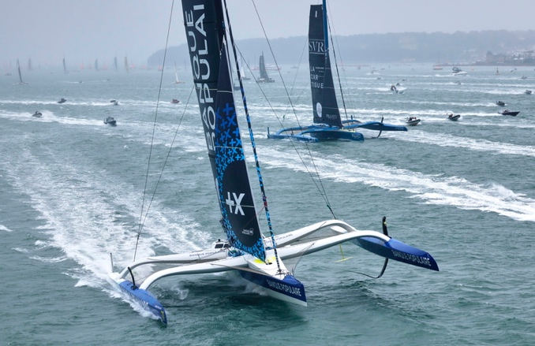Since her launch on 27 April 2021, *MAXI BANQUE POPULAIRE XI* has covered nearly 125,000 nautical miles - the equivalent of five laps around the globe. Now, the record-breaking trimaran will line up at the Rolex Fastnet Race, aiming not just to compete, but to win.

Representing Port de Lorient and sailing in the Classe Ultim, this cutting-edge ocean giant is crewed by some of the biggest names in offshore racing. The line-up includes Armel Le Cléac’h, Sébastien Josse, Pierre-Emmanuel Hérissé, Clément Duraffour, Sam Goodchild, Thierry Chabany, and Nicolas Lunven - all members of the elite *Team Banque Populaire*.

“Taking part in the Fastnet Race is a must,” says the team. “It’s an iconic race that everyone in our group values - and our objective is simple: to give everything, and go for the win.”

With a track record built on innovation, power, and relentless ambition, *MAXI BANQUE POPULAIRE XI* will be a standout in the fleet - racing not just for the line, but to make a statement on one of the sport’s most historic courses.

**Social Media:**Instagram: @voilebanquepopulaire  
Facebook: Voile Banque Populaire  
Website: [https://www.voile.banquepopulaire.fr](https://www.voile.banquepopulaire.fr/)

**Contact:**Delphine Gallais - delphine@agence-inspire.fr  
Phone: 06 26 25 20 50

**MOONPALACE targets top spot among sharp-bowed Class40s***MOONPALACE, Class40 / Pogo S3, Nicolas Guiba*l   
Port La Turballe, France - Class40  
Yacht clubs: Club SRT

*MOONPALACE* is a Pogo S3 Class40 skippered by Nicolas Guibal and based in Port La Turballe on France’s Atlantic coast. Built for offshore competition, the boat is part of the high-performance, sharp-bowed subset of the Class40 fleet - a configuration known for power, speed, and responsiveness in ocean racing conditions.

The team enters the 2025 Rolex Fastnet Race with a clear goal: *to be the first among the sharp-bowed Class40s*. It’s a focused challenge within the broader Class40 division - one that reflects the boat’s build and the team’s intent.

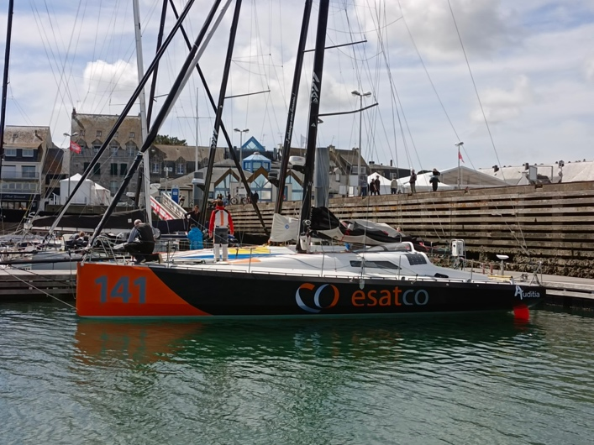

Beyond the results, the crew is also looking forward to the race’s unique environment. “We want strong visibility and great energy,” says Guibal - a nod to both the spirit of the Fastnet and the networking opportunity it brings.

**Social Media:**Facebook: <https://www.facebook.com/grandlarge.ng>LinkedIn: <https://www.linkedin.com/company/ng-grand-large/>Instagram: <https://www.instagram.com/ng_grand_large/>

**Top IMOCA campaign Paprec Arkéa returns for performance-focused Fastnet**Paprec Arkéa, IMOCA, Yoann Richomme, Lorient, France - IMOCA  
Yacht clubs: French Flag

*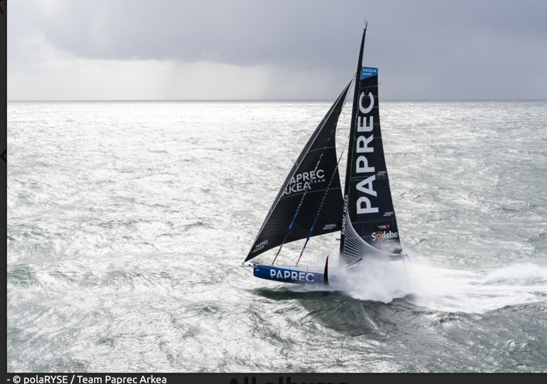Paprec Arkéa 24* is a cutting-edge IMOCA built by Multiplast and launched in February 2023. Designed by Antoine Koch and Finot-Conq, the boat has quickly established itself as one of the leading names in the IMOCA fleet - combining high-performance design with consistent results across the world’s most prestigious offshore races.

In just two seasons, *Paprec Arkéa* has secured a string of top finishes, including:

* 1st - 2024 The Transat CIC
* 1st - 2023 Retour à La Base
* 2nd - 2024 Vendée Globe
* 2nd - 2023 Rolex Fastnet Race
* 2nd - 2023 Transat Café L'Or

Now, the team returns to the Rolex Fastnet Race with a fresh focus: pushing performance further through a collaborative, crewed campaign. “After the first two seasons focusing on Paprec Arkéa's reliability, 2025 will be a very performance-oriented year,” says Yoann Richomme. “Sailing with a crew allows us to open up to other visions and explore new areas to improve. I think that’s great.”

This year's crew includes skipper Yoann Richomme - already a standout figure in the IMOCA world - alongside Corentin Horeau, Pascal Bidégorry, and Estelle Greck.

With a technical team that prizes precision and learning, and a platform that’s already proven itself on both sides of the Atlantic, *Paprec Arkéa* heads into 2025 with a clear aim: evolve, refine, and race at the highest level.

**Social Media:**Website: <https://www.teampaprecarkea.com/>Instagram: @paprecarkeateam  
Facebook: @Paprec Arkéa Team  
LinkedIn: Paprec Arkéa Team  
YouTube: PAPREC ARKEA Team  
TikTok: @paprecarkeateam

**Contact:**Isabelle Delaune - presse@teamspiritracing.fr  
Phone: +33 6 20 53 90 14

**Agite 40 to debut new Class40 in Fastnet sea trial***Agité40, Alexandre LE GALLAIS, Michel Desjoyeaux , Carlo Vroon  
La Trinité-sur-Mer,*   
France - Class40  
 Yacht clubs: French Flag

*Agite 40 (Trimcontrol*) will line up for the 2025 Rolex Fastnet Race as a brand-new Class40 entry - and a debut platform for the Agité40, a design developed by CT Mer Forte and built by Mer Agitée, the workshop of sailing legend Michel Desjoyeaux.

With the boat splashing in June 2025, the Fastnet will mark its first competitive outing, offering a real-world test of the team’s latest Class40 vision. “This should be the first race with this new Class40 we designed and build, and now here sail,” the team notes. “Hope she will achieve our goals of performance!”

It’s a milestone moment for a boat developed with ocean racing at its core - and the Fastnet is a fitting stage. “Each participation I made was special, different! This year’s will be too, for sure!”

The crew is small but sharp. As they put it: “One is building swimming pools, the other sails overseas!” With Desjoyeaux’s fingerprints on the design and a fresh hull beneath them, this Fastnet will be about more than just results - it’s a launch, a test, and a celebration of pushing into new water.

**Social Media:**Instagram: @micheldesjoyeaux

**Ex-Charal brings round-the-world pedigree to Fastnet with TeamWork Team Snef***TeamWork Team Snef, IMOCA, Lucile Troel Lorient,* France - IMOCA  
Yacht clubs: Centre Nautique de Lorient

Originally launched in 2018 as *Charal*, this cutting-edge IMOCA was designed for the Vendée Globe - the world’s toughest solo round-the-world race. Now racing as *TeamWork Team Snef*, the boat brings its ocean-tested pedigree to the 2025 Rolex Fastnet Race under a new crewed campaign.

“Really happy to go to the Rolex Fastnet Race, it's a race that I enjoy because I have a lot of great memories of the past races I did,” says Lucile Troel. “The big difference this year is that in IMOCA we are going to sail crewed. There will be even more intensity than the past years!”

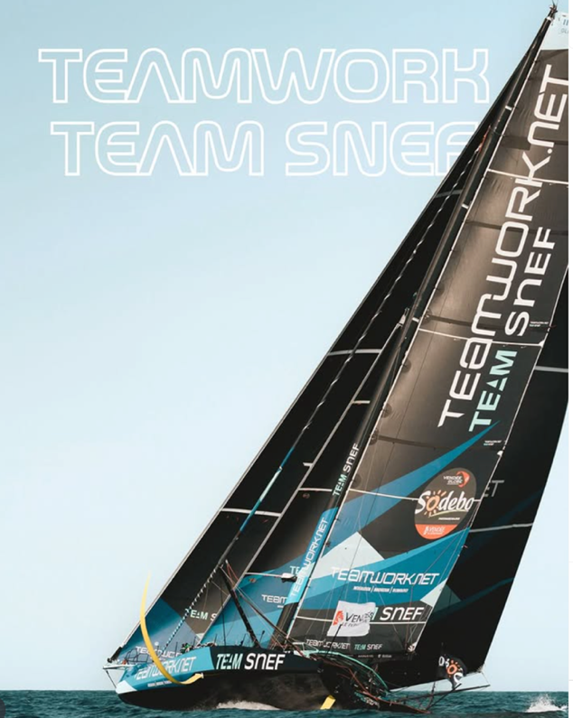The transition from solo to fully-crewed sailing brings new dynamics - more collaboration, strategy, and shared decision-making. “Yes! It's always a really interesting race, strategy wise as we have to round a lot of corners with currents and everything…”

Previously racing as *TeamWork* since 2022, the boat adopted its current name at the start of 2024. Now, under the Centre Nautique de Lorient, it joins a highly competitive IMOCA fleet for another go at one of offshore sailing’s most storied courses - this time with a full team on deck.

**Social Media:** Website:<https://teamwork-imoca.com/> Instagram: [@justine_mettraux](https://www.instagram.com/justine_mettraux/?hl=fr) Facebook: [Justine Mettraux](https://www.facebook.com/justinemettraux/?locale=fr_FR) LinkedIn: [Justine Mettraux](https://www.linkedin.com/in/justine-mettraux-5a119179/?originalSubdomain=fr)

**Contact:** Lucile Troel - luciletroel@hotmail.fr  
 Phone: +33 6 68 97 58 30  
  
**VASCO returns determined to round the Rock after hard-to-swallow 2023 exit***VASCO, Pogo 36, Bernard Fondrillon, La Trinité-sur-Mer,*   
France - IRC 1  
Yacht clubs: NT, RORC

Built in 2017, *VASCO* is the 12th Pogo 36 to come out of the Structures shipyard - a modern offshore racer with serious spirit. After a hard-to-swallow retirement in the 2023 Rolex Fastnet Race due to water ingress, skipper Bernard Fondrillon and his French crew are back with one clear mission: to complete the course they were forced to leave behind.

“First expectation is to complete the race,” Fondrillon says. “In 2023 we abandoned after 4 days due to water ingress - it took months to digest. So this time we want to round the Rock and finish. Then have fun, beat the other Pogos of the race.”

The crew, all from Brest, Nantes, and Paris, is made up of students and engineers - an all-French team ready to embrace the challenge. *VASCO* has unfinished racing goals and a very specific ambition: “We like the great departure in the Solent, and always a great return downwind from Fastnet. We would like to beat our speed record of 21 knots on the return from Fastnet.”

What they’re looking forward to most? “Departure with hundreds of boats in the Solent - highlight is certainly rounding Fastnet Rock.”

With lessons learned and motivation high, *VASCO* returns in 2025 with focus, fire, and an eye on both the finish and the fun.

**YESSS ELEC EAU returns to get to the finish line***YESSS ELEC EAU, JPK 10.30, Bertrand Fourmond*   
France - IRC 3  
Yacht clubs: Club Nautique de Lorient (CNL)

Built in 2021 for IRC offshore racing, *YESSS ELEC EAU* is a JPK 10.30 that has already covered over 14,000 nautical miles in competition, including the Armen Race, 45/5, and Rolex Cap Martinique. But despite all those miles, the Fastnet remains a box yet to tick.

Skipper Bertrand Fourmond, from Sablé-sur-Sarthe, is determined to change that this year. “Go and discover the Fastnet and the Irish Sea,” he says - a personal goal after 2023’s campaign was cut short. “In 2023, I broke my mainsail,” he adds. The boat had to retire, and finishing the course now carries special meaning. Asked what he’s most looking forward to this year, his answer is clear: “To finish it.”

Bertrand is joined by Éric Tilly, from Issy-les-Moulineaux, as the two-man crew takes on the course together. The boat is based in Locmiquélic (56) and represents the Club Nautique de Lorient.

Professionally, the team blends business and industry experience: Bertrand is a company director, while Éric works as a senior purchasing officer in a major firm. Together, they bring determination, resilience, and a shared ambition to finally cross the Rolex Fastnet finish line.

**Crew:** Bertrand Fourmond - Skipper, Éric Tilly - Crew

**Social Media:** Blog: [https://teampoussone.wordpress.com](https://teampoussone.wordpress.com/) Facebook: [facebook.com/teampoussone](https://www.facebook.com/teampoussone) Instagram: [@skipperbertrand](https://www.instagram.com/skipperbertrand)

**Contact:** Céline Fourmond Email: [teampoussone@gmail.com](mailto:teampoussone@gmail.com), Phone: +33 6 27 50 01 01

**Zephyrin pushes the limits with Fastnet adventure***Zephyrin, Jeanneau Sun Fast 3200, Pierrick Penven*   
France Brest - IRC Double  
Yacht clubs: Yacht Club de la Rade de Brest

Launched in 2012, *Zephyrin* is a Jeanneau Sun Fast 3200 - a reliable, race-proven design now gearing up for the 2025 Rolex Fastnet Race. For co-skippers Pierrick Penven and Fanch Le Guern, the goal is to have fun, push their boat, and stay competitive against newer designs.

“To do a nice race, having fun at sea with friends,” says Penven. “Pushing the limits of *Zephyrin*. Trying to keep up with the new designs.”

Representing the Yacht Club de la Rade de Brest, the French duo will sail doublehanded from Cowes to Cherbourg via the iconic Fastnet Rock - driven more by passion than pressure. Their motivation is simple: “Having fun at sea.”

Between them, they bring the right tools for the job: one oceanographer, one sailmaker - a blend of science, precision, and hands-on experience.

Crew:Pierrick Penven - Skipper, Fanch Le Guern - Co-skipper

**The Kelbert-Loison duo is back**

*Léon, JPK 1050, Alexis Loison*

L’Armen Race Uship was the first offshore race of the season for Léon, the JPK 1050, with Alexis Loison alongside Jean-Pierre Kelbert, once again.   
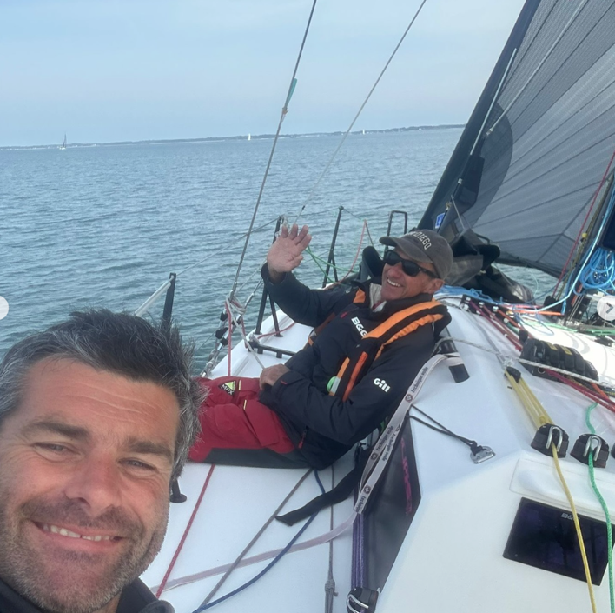  
  
“Objectives are widely met, despite the light conditions:-  
- Very nice speed phases in all conditions.  
- An excellent test gallop for Leon.  
- And above all, a valuable training and qualification for the Rolex Fastnet Race. It was a demanding course, interesting tactical choices from start to finish, perfect to kick off the season. Next stop - the Rolex Fastnet Race, in July. But before that we meet in June for the continuation of the Figaro season on [@tbvoile](https://www.instagram.com/tbvoile/),”  
says Alexis Loison.

Cherbourg’s Alexis Loison has previously won his class four times in the Rolex Fastnet Race, on each occasion also coming out on top in IRC Three/Four, including 2013 when, with his father Pascal on the JPK 1010 Night and Day, they won the race outright – to date the only doublehanders to achieve this.   
  
[@jpkcomposites](https://www.instagram.com/jpkcomposites/) [@incidencesails](https://www.instagram.com/incidencesails/) [@yachtclubcherbourg](https://www.instagram.com/yachtclubcherbourg/) [@snt56470](https://www.instagram.com/snt56470/)

<https://www.instagram.com/alex.loison/>

**Actual Ultim 4 lines up for Fastnet with self-made Marchand at the helm**

*Actual Ultim 4, Ultim Trimaran, Anthony Marchand,*Lorient, France - Ultim

Originally launched as Gitana 17, Actual Ultim 4 is one of the fastest and most technologically advanced offshore racing trimarans in the world. Now racing under new colours with skipper Anthony Marchand, the boat begins a new chapter in the Rolex Fastnet Race 2025-marking the first time this particular team campaigns the 32-metre Ultim in the event.

Gitana 17 previously amassed one of the most impressive winning records in the Ultim class, collecting eight major victories in less than five years. The boat is a concentrated mix of innovation and power: 32 metres long, 34 metres high, capable of speeds over 50 knots, and equipped with 2 km of rope, 300 sensors, and 350 metres of fibre optic cable-all supported by a land-based simulator and an engineering team of six to eight specialists.

Anthony Marchand took the helm of Actual Ultim 4 in January 2023 and finished the solo ARKEA Ultim Challenge-Brest in early 2024. A discreet but ambitious sailor, he has logged over 300,000 km in offshore racing and is regarded as one of the most talented sailors of his generation. Remarkably, he is entirely self-made – no one in his family had ever stepped foot on a boat before him.

Backing the project is Actual Group-one of France’s largest employment and social integration organisations, with 600 agencies and €1.5 billion in revenue in 2024. A longtime supporter of offshore racing, Actual has been active in the sport for 24 years and recently strengthened its involvement with the acquisition of this elite multihull to race in the Transat Café L'Or and other top-level ocean events.

Samuel Tual, president of Actual Group and newly elected president of the Ultim class, is deeply invested in the sporting world, supporting initiatives across sailing, rugby, boxing, freediving, and football.

The team is enthusiastic about engaging with media and happy to offer press access or visits to their base.

Contact: [laurence.caraes@kaori.fr](mailto:laurence.caraes@kaori.fr)

**GERMANY**

**X-Men or “underdog”?**

*Friesisch-X, X-Yacht X-99, Paul Giese – IRC4*

Horumersiel, Niedersachsen

Yacht Club: Segelkameradschaft Horumersiel

*Friesisch-X*, co-owned by skipper Tanno Kruse, Peter Burlager and Paul Giese, will be sailed by a group of friends that started sailing together on an X-79 a few years ago.

Paul explains: “In 2020, we were the only boat that sailed around Skagen during the Covid lockdown, while thousands of sailors only sailed virtually. Sailing a course like this on a X-79 was something special and, in 2023, we decided to take the next step and buy a X-99.”

For some crew members, this will be the third time doing the Fastnet, for others, it will first time.

Paul comments on their expectations: “Being the underdog, we are simply hoping to finish the race and return to shore safe and sound. However, since we have another X-99 in IRC 4 that was able to beat us in the previous Pantaenius Round Skagen, this will be the real competitor in the race.”

Being a non-professional crew from Germany, there are some logistics involved to get the boat and its crew to the race and back home. We are looking forward to summer filled with offshore sailing. The number of yachts participating in the race and the course are something truly special.”

Tanno Kruse, German, Waddewarden, Co-Owner and Skipper (Boatbuilder Master), Peter Burlager, German, Oldenburg, Co-Owner and Co-Skipper (Workshop Manager), Paul Giese, German, Bad Zwischenahn, Co-Owner and Bowman (Offshore Service Engineer)

Ole Achim Eden, German, Esens, Helm (Police Officer)

Hendrik von Bodungen, German, Wangerland, Trimmer (Shipbuilding Engineer)

Instagram: friesisch_x

**Contact: Onboard reporter: Paul Giese -** [**ger509.x99@gmail.com**](mailto:ger509.x99@gmail.com)

**German Contessa returns to racing roots for Fastnet***Con-Tiki, Contessa 35, Jens Riewe*   
Germany- IRC

Built in 1976, *Con-Tiki* is a classic Contessa 35 with deep racing pedigree. Originally known as *Shark VI*, she competed in the Danish racing circuit throughout the late 1970s and early 1980s. After spending much of her life in the Danish Baltic, she found a new direction in 2021 when current owner and skipper Jens Riewe brought her back to life as a racer.

“Con-Tiki and I started moving together in 2021,” says Jens, who skippered her in the 2024 Baltic Sea Race. Despite finishing last, the boat was welcomed into the marina with warmth and camaraderie from fellow competitors - a moment that perfectly captured the Corinthian spirit Jens values most.

That same ethos carries through to the team’s goals for the 2025 Rolex Fastnet Race: to complete the course safely, with strong teamwork and good humour. “Corinthian style - finishing the race safe and sound,” he says simply.

The crew is a tight-knit group of German sailors: Jens, Marcus, Rainer, Holger, and Kay. For them, this race is as much about the shared experience as the sailing. “We’re looking forward to the atmosphere of Cowes and Cherbourg - and having a good time on board with a fabulous crew.”

With her long history and quietly proud comeback, *Con-Tiki* brings a classic design and a classic spirit to this year’s race.

**Contact:** Jens Riewe - jens@jensriewe.com  
+49 1525 2907700

**German Corinthian crew sets sights on Fastnet milestone***EXCEPTION, X-99, Design by Niels Jeppesen, Joerg Meissner*   
Hooksiel, Germany - IRC 4  
Yacht clubs: Wilhelmshavener Segelclub

*EXCEPTION* is an X-99 designed by Niels Jeppesen and built by X-Yachts in Denmark. With an extensive background in North Sea and Baltic offshore racing, the yacht has competed in events such as Kieler Woche, Silverrudder (singlehanded), Rund Skagen, and the Horumregatta. Continuously maintained and upgraded, she is now fully equipped for offshore racing under ISAF Offshore Special Regulations, with modern navigation, rigging, and safety systems.

Representing Germany and sailing under the burgee of Wilhelmshavener Segelclub, *EXCEPTION* is making her debut in the Rolex Fastnet Race. For this Corinthian team, the aim is clear: “To take part, round the Rock, and reach the finish line safely - together.”

“We’re most looking forward to the moment we round Fastnet Rock,” says skipper Joerg Meissner, who also acts as media officer. “It’s the emotional highlight of the race. Sharing this experience with hundreds of other sailors, managing the boat and ourselves for several days at sea - that’s the challenge we respect and want to be part of.”

The crew is a tight group of passionate sailors from Germany and the UK: Vanessa Werner - Wilhelmshaven - Foredeck, Olav Schluter - Southampton/Bremen - Tactician, Birk Veith - Jever - Co-Skipper, Martin Kersting - Bremen - Foredeck, Joerg Meissner - Oldenburg - All-rounder/Media Officer.

Professionally, they represent a wide mix: a general practitioner, a police officer, a student, an academic, an architect, and a pharmaceutical technical assistant. What unites them is a love for the sea, a commitment to teamwork, and a drive to complete one of the world’s great offshore races as a crew.

“We’re not here for the podium,” Joerg adds, “but for the experience - seamanship, endurance, and the shared moments that define this race.”

**Social Media:** None - amateur team, no official channels  
**Contact:** Joerg Meissner, Germany  
Email: joerg.meissner@gmx.net

**German student team returns to Fastnet with club-raced Sun Fast 3600***Löwe von Bremen, Sun Fast 3600, Gyde Hansen Bremerhaven,*   
Germany - IRC 2  
Yacht clubs: Segelkameradschaft "Das Wappen von Bremen"

*Löwe von Bremen* is a Sun Fast 3600 operated by the student-led youth section of the German sailing club *Segelkameradschaft "Das Wappen von Bremen"*. Built in 2016 and acquired by the club in 2022, the boat is entirely self-managed by young sailors aged between 23 and 35. Four of the current crew raced the 2023 Rolex Fastnet Race aboard *Löwe von Bremen*, marking their first experience with the race and with offshore sailing at this distance.

That debut campaign had one simple goal: to cross the finish line. Not only did they succeed, but they also placed ahead of the other German club boats - including their friendly rivals on *Schlüssel von Bremen*. For 2025, the focus is on continued growth. “We want to improve our tactical and navigational decisions and have an awesome race with a well-prepared crew,” says main trimmer Gyde Hansen. “We’re especially focused on refining our routing strategy and watch system.”

The team includes: Frederick Nabor - Skipper - Bremen, Carolin Bosselmann - Jib trim - Hamburg, Jari Krebs - Gennaker trim - Bremen, Lasse Seeger - Bow - Kiel, Tom Denker - Pit - Bremen, and Gyde Hansen - Main trim - Husum.

All are students in various disciplines: law, mechanical engineering, medicine, sports science, political science, and journalism. This is a truly Corinthian campaign - youth-driven, self-organised, and determined to grow through experience.

“We’re really looking forward to the 2025 edition,” says Hansen. “It’s a chance to progress as sailors, work together under pressure - and maybe even beat *Schlüssel von Bremen* again.”

**Social Media:** Website: [https://www.skwb.de](https://www.skwb.de/)Instagram: @skwb.ev  
Facebook: skwb e.V.

**Contact:** Gyde Hansen - gyde.hansen@proton.me  
Phone: +49 172 9058816  
  
**German training yacht Peggy joins Fastnet for the first time***Peggy, X-332, Ferdinand Muth, Glücksburg*,   
Germany - IRC 4 (pending)  
Yacht clubs: DHH e.V (Deutscher Hochseesportverband Hansa)

*Peggy* is a 1998 X-332 generously donated to the Deutscher Hochseesportverband Hansa (DHH) by the Eberhard Wienholt Stiftung. Since then, she has been actively used for offshore training and regatta sailing - all under the guidance of volunteer instructors. For the 2025 Rolex Fastnet Race, *Peggy* will take on her biggest challenge yet: lining up with the IRC 4 fleet for the first time.

“Our main goal is pretty simple,” says skipper Ferdinand Muth. “Finish the race with both our crew and *Peggy* in good shape. If we can manage that, we’ll be happy. And of course - if we don’t finish last, that’s a bonus!”

The crew is a mix of students and professionals from across Germany: Sönke Mühlfeld, Knud Oldoerp, Dr. Alexander Lüllmann, Amelie Steinbrinker, Mira Marx, Jonathan Bundies, and Ferdinand Muth.

Professionally, they bring together a dentist, a politician, a lawyer - and four students - but offshore, they’re one team with one goal: to complete a race they’ve dreamed about for years. “Just being part of the Fastnet is what we’re most excited about,” says Muth. “Lining up at the start is already something special. We can’t wait to soak up the atmosphere and share the experience.”

With strong club backing, a teaching mission at heart, and a modest but determined outlook, *Peggy* is a true Corinthian entry - racing for the love of the sport, and for the experience of doing it together.

**Social Media:**Instagram: @peggy_ger5338

**SAGITTA crew sets out to relive the magic of the Rock***SAGITTA, Albin Stratus, Tillmann Frank Glücksburg,* Germany – IRC 3  
Yacht clubs: Flensburger Segel-Club

Built in 1982 by Albin Yacht in Sweden, *SAGITTA* is a well-loved classic helmed by Tillmann Frank and based out of Glücksburg. Representing the Flensburger Segel-Club, the boat and her tight-knit crew return to the Rolex Fastnet Race with a clear and meaningful goal: to finish the race once again - and relive the powerful moment of rounding the Fastnet Rock.

Skipper Tillmann Frank is joined by a trusted team: Bernd Meier - Kiel - Watch captain, Lasse Frank - Rastorf - Routing and crew, Bernhard Outzen - Flensburg - Foredeck, and Marwin Outzen - Eberswalde - Routing and foredeck.

Together, they form a multi-generational, mixed-profession crew built on experience and camaraderie. Tillmann runs a biotech company focused on biological plant protection products, where Lasse also works. Bernd is a freelance energy adviser, Rio is a doctor, Bernhard is a teacher, and Marwin works in sustainability.

For this crew, the Fastnet isn’t about headlines or podiums. It’s about coming back together on a boat with history, sharing the challenge of the sea, and feeling that quiet thrill of seeing the Rock again - and knowing they earned it.  
  
**Admirals Cup inshore crew takes on offshore test aboard X-DAY***X-DAY, Fast 40 / GP42, Lars Hueckstaedt*Germany - IRC 0  
Yacht clubs: Plöner Segler Verein, RORC, Greifswald Admirals Cup Team

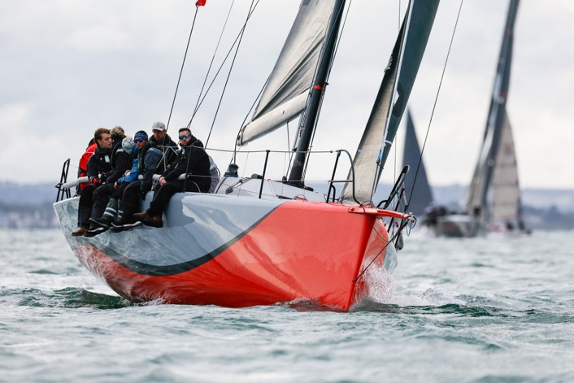Originally built for the GP42 MedCup, *X-DAY* is a high-performance racer that has evolved into a serious offshore contender. Now updated to meet the demands of the British Fast 40+ class - including the addition of water ballast for offshore performance - the boat joins the 2025 Rolex Fastnet Race with a fresh challenge and a crew crossing over from the Admiral’s Cup inshore series.

“It is going to be wet and stressful after all the inshores for the Admirals Cup,” says skipper Lars Hueckstaedt. “But it is going to be an epic experience.”

Representing the Plöner Segler Verein and racing under the Greifswald Admirals Cup Team, X-DAY brings a crew that blends German engineering talent with British and Australian race experience. They include: Lars Hueckstaedt (Germany, Plön) - Skipper, Walter Watermann (Germany, Dortmund) - Runners, Ole Paulsen (Germany, Hamburg) - Main, Henning Günther (Germany, Hamburg) - Pit / Navigation, Tobias Merkel (Germany, Flensburg) - Trimmer, James Brown (UK, Hamble) - Bow, Nick Sherry (UK, Lymington) - Tactics / Navigation, Will Sargent (Australia) - Tactics, Steve Aiken (UK, Southampton) - Trimmer, and Katharina Tietz (Germany, Hamburg) - Floater

The team blends deep technical know-how with frontline race talent: Tobias Merkel works as a designer for X-Yachts, and Ole Paulsen is a carbon fibre expert specialising in high-performance dinghy centreboards.

*X-DAY* will be looking to convert inshore performance into offshore results - and take on IRC 0 with full-speed focus.

**Social Media:**  Instagram: [@xdaysailing](https://www.instagram.com/xdaysailing/) Facebook: [X-Day Sailing Team GER 8419](https://www.facebook.com/XDaySailingTeamGer8419/)

**Contact:** Lars Hueckstaedt - lh@hueckstaedt-ploen.de

**HONG KONG**

**Keen for a taste of offshore racing in Europe -   
Rolex China Sea Race Winners**

*Whiskey Jack, J/122 2.2, Nick Southward*

Hong Kong – IRC2

Yacht Club: Royal Hong Kong Yacht Club

Whiskey Jack is a well-known name in the world of offshore racing, particularly in the Far East.

Owner/skipper Nick Southward says of this race: “The core of the crew sailed with me on my other Whiskey Jack (a J/109) when we won the Rolex China Sea Race in 2023. We also sail together on many other races around the waters of Hong Kong. I'm fortunate enough to have been able to persuade them to join me in England for the Rolex Fastnet, and to be able to add some local knowledge into the mix. The boat is a J/122, so quite similar in nature, but hopefully will get us there a little quicker!”

The crew is a group of friends with Hong Kong histories, who have sailed together a lot. There is also one father/son combo “to keep our average age down!” There is a range of offshore experience on board. For some, this will be the first Fastnet, others have done many. In total, across the crew, they have competed in 20 Fastnets, including two as double handers.

Their objective this time is: “to test ourselves against a high-quality fleet. Having won one Rolex offshore race, we have come to the home of offshore racing to experience just how hard it really is. The appeal of the Fastnet is its history, its scale, and the range of conditions that will be encountered along the way. Our biggest challenge is putting together a complete package (people, equipment, food, training, tech, safety) to be able to deal well with whatever conditions we are dealt with.” 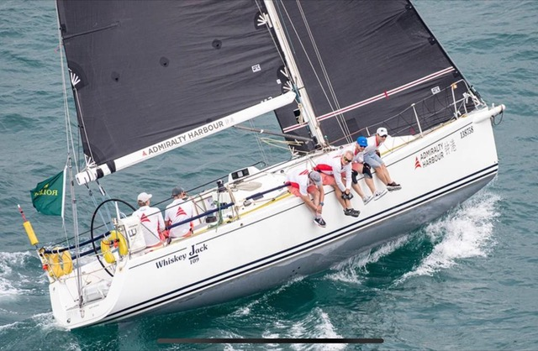

Nick Southward - British Skipper

Mick McCool - British/Irish Navigator

Peter Davies - British Crew

Tom Carter - British Crew

Chris Preston - Swiss/British Crew

Dan Tullberg - Swedish Crew

Oskar Tullberg - Swedish Crew

Professions onboard are pretty varied: civil engineer / process consultant / teacher / wingfoil manufacturer / educator / yacht broker / sailmaker. Which one of these is interesting, depends on who you are talking to!

**Contact: Peter Davies -** [**peter@lanikaibeachhouse.com**](mailto:peter@lanikaibeachhouse.com)

**Social Media contact:** Lana Davies - [lanamdavies@icloud.com](mailto:lanamdavies@icloud.com)

<https://www.instagram.com/whiskey.jack.j122?igsh=MWZrZG16MW9lZDY1bA%3D%3D&utm_source=qr>

[https://www.facebook.com/profile.php?id=61576787262347&mibextid=wwXIfr&rdid=ouV58UgV5k5friMA&share_url=https%3A%2F%2Fwww.facebook.com%2Fshare%2F19DKBPubHc%2F%3Fmibextid%3DwwXIfr#](https://www.facebook.com/profile.php?id=61576787262347&mibextid=wwXIfr&rdid=ouV58UgV5k5friMA&share_url=https%3A%2F%2Fwww.facebook.com%2Fshare%2F19DKBPubHc%2F%3Fmibextid%3DwwXIfr)

**Beau Geste and Beau Ideal: A legacy continues at the Admiral’s Cup**

*Beau Geste, TP52 (2018 Botin Design), Karl Kwok (Owner)/ Gavin Brady (Skipper) – AC1*

Hong Kong, China

Yacht Club: Royal Hong Kong Yacht Club

Beau Geste Racing returns to the global stage of offshore sailing with a powerful two-boat campaign representing **Hong Kong-China** in the prestigious **Admiral’s Cup**. Spearheaded by long-time owner **Karl Kwok**, this seasoned and successful team brings a legacy of excellence, speed, and seamanship that stretches across decades:

* **6th Time / 6 Races**: Reflecting a remarkable campaign history
* **IRC European Winner**: 2023, 2024
* **ORC World Champion**: 2022, 2023
* **Admiral’s Cup Campaigns**: Fastnet Race veteran, with three campaigns since 1995

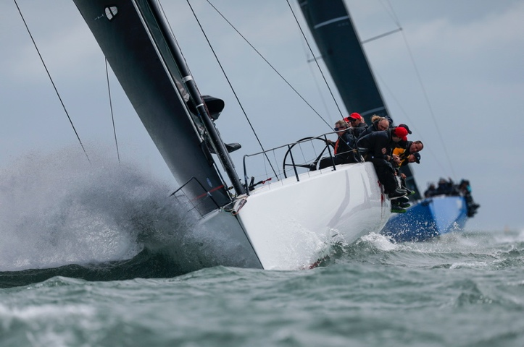

Karl Kwok competed in the Admiral’s Cup in 1995, and has raced in three Fastnet Races with Beau Geste since 1995.

Gavin Brady:

[bradymarine97@gmail.com](mailto:bradymarine97@gmail.com)

**New build for Admiral’s Cup & Fastnet**

*Beau Ideal, Fast 40 (2024 Botin Design), Karl Kwok (Owner) – AC2*

Hong Kong, China

Yacht Club: Royal Hong Kong Yacht Club

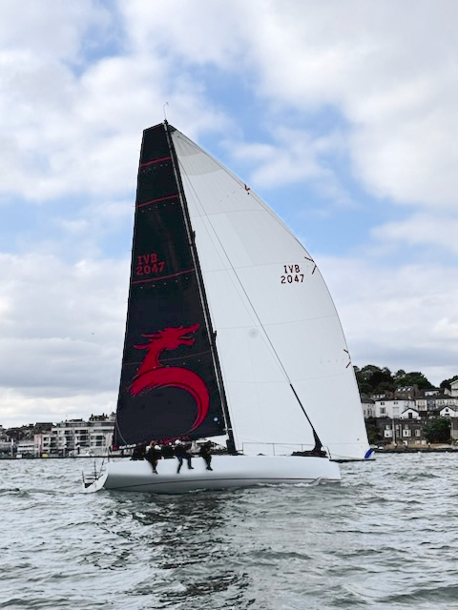

Brand new build for the 2025 Admirals’ Cup. Purpose-built for competitive racing in Class 2.

Emphasizing close racing, agility and performance, it is hoped she will do well over the long distance and in tough conditions. She complements Beau Geste in the team’s full-scope strategy from inshore races to the Rolex Fastnet Race.

Gavin Brady:

[bradymarine97@gmail.com](mailto:bradymarine97@gmail.com)

**ITALY**

**Italian skipper returns with Influence2 and eyes the Class40 podium***Influence2, Musa40 - Class40, Andrea Fornaro*  
Rome, Italy - Class40  
Yacht clubs: Circolo Canottieri Aniene

*Influence2* is a 2023-built Musa40 skippered by Italian offshore racer Andrea Fornaro. Representing Circolo Canottieri Aniene in Rome, the boat is part of the highly competitive Class40 fleet and brings serious miles under her keel, including a previous Rolex Fastnet Race, the Transat Jacques Vabre, the Niji40, and numerous other Class40 events.

This year’s Fastnet marks another milestone in Fornaro’s campaign, and the objective is clear: “I hope to win this race,” he says. “We’ve prepared the boat at its best.” While many look forward to the scenery or camaraderie, Fornaro is focused on performance - though he adds a small wish for “pleasant weather conditions to enjoy this beautiful route.”

With a boat purpose-built for speed and a skipper well-versed in long-distance offshore racing, *Influence2* will be one to watch in the Class40 fleet as they tackle the 695-mile course from Cowes to Cherbourg via the iconic Fastnet Rock.

**Social Media:**Website: [www.andreafornaro.net](http://www.andreafornaro.net/)Facebook: Andrea Fornaro Navigatore  
Instagram: @andrea_fornaro_navigatore

**Contact:**Francesca Magnini - francescamagnini@gmail.com  
+39 339 882 7492

**New boat built for Admiral’s Cup and Rolex Fastnet**  
*Django WR51, Wallyrocket 51, Giovanni Lombardi Stronati, Admiral’s Cup class  
Italy + La Spezia + Yacht Club Costa Smeralda (YCCS)*

Django WR51 is a Wally Rocket 51, a high-performance racing yacht built in 2024 by Botin with Wally Yachts.  
“We are representing Italy and love the history of the Admiral's Cup and are going to have a shot at winning it,” says Rachele Vitello. “The Rolex Fastnet is a great offshore classic, with its history and the legends who have raced in it. That’s what makes it so special. The highlights will be the start of the race and the rounding at the Fastnet lighthouse.:

“Vasco Vascotto is one of Italy's most celebrated skippers, with 30+ one design world championship title wins. The Wally Rocket 51 Django team is 99% made of Italian sailors, all experienced, mostly above 45 years old, but some of them are younger promising sailors.

Instagram: <https://www.instagram.com/team__django/>

Media contact: Rachele Vitello, [rachele.vitello@gmail.com](mailto:rachele.vitello@gmail.com)

**MALTA**

**Professional crew serve a good hand**

*Black Jack 100, R/P 100, Remon Vos (Owner)*

Malta - IRCSZ

Yacht Clubs: Malta + Valetta + Yacht Club de Monaco

© Alex Turnbull/Black Jack 100  
  
Remon Vos (Groningen, NL), a 1961 Fastnet line honours winner, returns to the international offshore stage, this time leading *Black Jack*, a powerful supermaxi with proven pedigree. While this will be Vos’ first participation in the Fastnet, he brings deep competitive sailing experience from his ClubSwan50 campaigns, and he’s assembled a formidable international crew to match his ambition.

Built in 2005, Black Jack 100 previously campaigned as Alfa Romeo and Esimit Europa, both legendary names in offshore racing. Now reborn as *Black Jack*, the boat underwent a major refit during the winter of 2024, with rigorous sea trials completed in April. With its extensive upgrades and optimized performance, *Black Jack* is poised to contend fiercely for line honours in the IRC class. A group of people on a sailboat

“We are aiming for the line honours in IRC, but it will be a big challenge with some other strong supermaxis in the fleet,” said Vos. “It will all come down to skill, preparation, and a little bit of luck with the weather.”  
The Fastnet Race is notorious for its unpredictable conditions. From navigating congested waters at the start to enduring offshore pounding in potentially boat-breaking conditions as in 2023, the team knows it must be sharp from start to finish.

Many of the crew members became close friends while racing together, and mid-2024 saw Vos purchase the boat and bring in this core group from his ClubSwan50 program. With a few key new additions, Black Jack now fields one of the most internationally diverse and experienced teams in the fleet, blending proven offshore experience with Olympic and America's Cup pedigree.

Led by skipper Tristan Le Brun, who competed in the 2023 Ocean Race with Team JAJO (VO65) and secured a second place in IRC Overall on handicap in the 2023 Fastnet Race, the team will be looking to better that result.

“What makes the Fastnet so special is the sheer scale – so many big boats, the history, and the electric atmosphere at the start,” said Le Brun. “Getting clean off the line, overtaking the smaller boats early, and then pushing hard offshore – it’s everything we love about offshore racing.”

For Black Jack, the focus is clear: a good battle with the other supermaxis and, hopefully, a win for the team.

Crew highlights:

Thierry Fouchier (FRA) - 6x Americas Cup

Andrew Henderson (AUS) - (4x Americas Cup)

Sofian Bouvet (FRA) - 2016 Olympic Games, 470 Class

Rokas Milevičius (LTU) - 2x Ocean Race

Jelmer van Beek, Rutger Vos, Max Deckers, Jorden van Rooijen – all with Ocean Race experience

For Black Jack, the focus is clear: a good battle with the other supermaxis and, hopefully, a win for the team.

Contact: Jelmer Van Beek - [jelmervanbeek@icloud.com](mailto:jelmervanbeek@icloud.com)

+31 6 1231 2706

Onboard Reporter: Alex Turnbull

[alex@alex-turnbull.com](mailto:alex@alex-turnbull.com)

instagram blackjackyachting   
Facebook Black Jack Yachting

**1961 Fastnet line honours winner – will she excel for third consecutive Fastnet?**

*Stormvogel, 22.6m ketch,* Ermanno Traverso*, Skipper: Tom Ripard*

Italy/Malta

Stormvogel is one of the post-WWII ‘modern classics’, itself one of the most successful yachts of the 1960s. Launched in 1961 for the Dutch plywood tycoon Cornelius Bruynzeel, Stormvogel claimed line honours in that year’s Fastnet before heading off on a tour of the globe’s top offshore races including Newport-Bermuda, Gotlund Runt, Transpac, Sydney Hobart, China Sea Race, Middle Sea, etc. Despite being over 60 years old, Stormvogel finished 7th overall in the 2021 Rolex Fastnet Race and she was 11th among 358 IRC starters and 6th in IRC Zero in 2023. Thanks to the scrupulous care and maintenance carried out on this van der Stadt/Laurent Giles 74-footer on behalf of her ‘custodian’ of the last 40 years, Italian Ermanno Traverso, Stormvogel is raced as hard today as she was by her original owner 62 years ago.

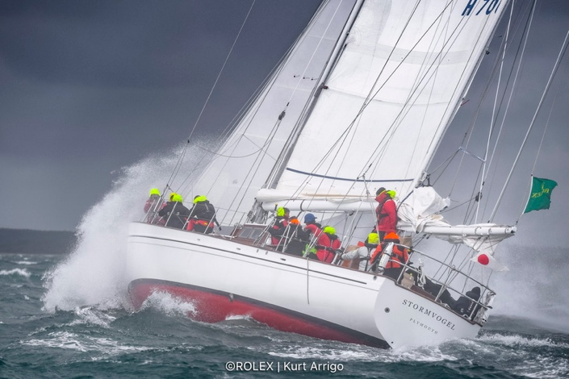

Clearly the race is special for the boat, as Ermanno Traverso observes: “The Fastnet was the first race that Stormvogel ever did and she won line honours. It was a complicated race. It was like my early days of sailing around the world in the 1980s, with just a sextant and barometer.”

Having owned and raced Stormvogel for more than four decades during Traverso’s tenure, she has undergone several refits which is why she not only appears immaculate, but judging from how she survived the last two Fastnet races, is also just as strong as when she was first launched.

**THE NETHERLANDS**

**Passion, persistence and team spirit**

*Barcarolle 2, Salona 42, Jaap Gelling – IRC2*

Delft, Netherlands

Barcarolle 2 was built in 2006/2007 and spent her first three years under the ownership of OneSails Croatia, who campaigned her intensively on the racing circuit.

After that period, her racing rig and keel were replaced with cruising versions, and she was put up for sale in the Netherlands. Jaap Gelling bought her at the end of 2010, and since then, she has brought a great deal of joy—both cruising and racing.

The lower cruising rig is quite suitable for comfortable cruising, although we do feel under-canvassed in light air. This is somewhat offset in the ORC triple-number system—but unfortunately not in the IRC single-number rating. The original cruising keel proved to be a handicap in racing, so we replaced it with a more performance-oriented keel a few years after purchase.

Jaap commented: “Although we will sail the Fastnet Race to the best of our efforts, we do not expect to achieve a high result. The reason is that it is the first time we sail the Fastnet - and the race is known for complex currents. So, (lacking) local knowledge will play a serious role. So, we are in for experiencing the great event and we will race fanatically - but we won't be disappointed when we don't end on the podium!”

In 2023, Barcarolle 2 made it to the start line, only for the mainsail to fail an hour before the gun. Conditions were reasonable—about 20 knots of wind—and the sail was relatively young and well maintained. It was a frustrating setback, but one they’ve moved past with renewed determination.

* **Racing History:** **With our own boat:**  
  Regular club racing, Colin Archer Memorial Race (Netherlands–Norway), Scheveningen 500 (Netherlands–St. Malo via Eddystone Rock)
* **As crew on other boats:** Multiple Swan Cups aboard a Swan 601**,** Two editions of Round the Island Race (on a ClubSwan 42 and a Swan 45)**,** ARC (Gran Canaria to St. Lucia) aboard VO65 Brunel

Of his team, Jaap said: “We have been racing together in the Dutch winter series for over a decade. While summers typically see us spread across our own boats, this year is different—we're reunited for the Fastnet qualifiers and the race itself.

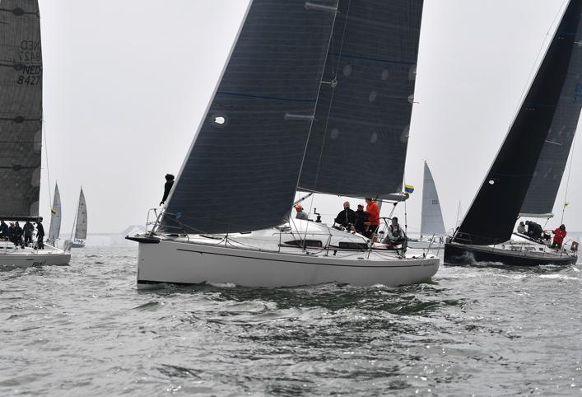

We are a group of sailing friends—my son has also been part of the team for about eight years. While none of us are professional sailors, we have a strong maritime background: three naval architects, maritime officers, software engineers, yacht builders—most with technical degrees (BSc/MSc). Many work in the maritime sector, including offshore operations, shipyards, consultancy/Delft University. One crew member works at the renowned superyacht builder Royal Huisman, and another is involved in yacht building at Pegasus.

I'm a RORC member since 2019.

“Rounding the Rock, and doing it as a team, will be amazing. The history, the huge fleet, the tactical course, often challenging weather conditions, etc...we can't wait to get started!”

Olaf Roeleveld - fore deck / mast

Edwin van den Hout - fore deck / mast

Marko Pas - all sail trim / pit / helm

Olivier Stuip - headsail / spi trim

Wouter Gelling - headsail trim

Evert de Wit - main sail trim / helm

Coen Bouhuijs - 2nd skipper / navigation / tactics

Jaap Gelling - 1st skipper / helm / navigation / tactics

**Contact: jaap@jlgelling.nl**

**Corinthians seek best of themselves and the boat** *Xantho, XP44/X-yachts, Jochem van der Wal (Owner)/Remco Schilderinck (Skipper) – IRC1*

Terschelling

Xantho NED4416 was build #100 in 2016 and was refurbished by the X-Yachts service department at the end of 2023.

For some of the crew, this is their third or fourth time participating in the Fastnet. As a skipper, this edition will be Remco Schilderinck’s third time, although first with Xantho. Remco commented: “We expect to be faster than other years, and our goal is to finish in the top hundred. If we have the same weather as in 2023, the main goal will be to get out of the Solent safely. Furthermore, it is important to endure 4 to 5 days in changing conditions. If the weather conditions are severe, that is a big challenge. We have prepared ourselves as a team for that, but, in the end, you never know what will come your way.”

The team, a diverse group of men aging from their 30s to 60s, with lots of offshore experience, was put together at the end of 2024 with the goal of sailing in the Rolex Fastnet Race in 2025 and the Round Britain and Ireland Race in 2026. The training programme included the IJspegelraces (short course races) off the coast of Scheveningen, and some longer offshore training. Some of them have followed RYA YM Offshore sailing courses at the Dutch Offshore Sailing Academy. One of the crew members will participate in the Clipper Round the World Race next year. Most of them also own their own cruising boats.

In terms of Remco’s personal sailing history: “I have been sailing since I was 13, and, for the past 16 years, I have been an offshore sailing instructor at the Dutch Offshore Sailing Academy. In 2018, I joined a racing team in preparation for the Rolex Fastnet Race 2019. In 2021, I was the co-skipper/navigator, and in 2023, the skipper/navigator on Windshift NED8489, a Varianta 44. I am a certified RYA Yacht Master Offshore Instructor Sail.”

The other crew members have various professions: a tax lawyer, transporter, director/manager, senior buyer, expert in logistics, project management, liaison at the Ministry of Defence and senior digital transformation manager.

**https://my.yb.tl/xantho**

**Contact: Remco Schilderinck -** [**info@remcoschilderinck.nl**](mailto:info@remcoschilderinck.nl)

**Feverishly good fun**

*FEVER, J/35, Simeon Tienpont*

‘s-Gravenhage, The Netherlands – IRC4

Yacht Club: JCS (Jachtclub Scheveningen)

The Dutch sailing friends ‘s-Gravenhage onboard Fever (1984 build) are joining the Rolex Fastnet to “sail a neat race from start to finish, and have a good time!”

Skipper Simeon Tienpont commented: “The most challenging thing will be the luck of timing and good tactical decisions at the finish, considering the strong currents in France.”

**Contact: Simeon Tienpont -**

[**simeon@steamoceanracing.com**](mailto:simeon@steamoceanracing.com)

**Dutch sailors go two-up for Fastnet adventure***IL CORVO, JPK 10.30, Astrid de Vin - Double Handed,   
IRC 3*Breskens, The Netherlands.

Yacht clubs: RORC, WV Breskens, WV Wolphaartsdijk, RSYC

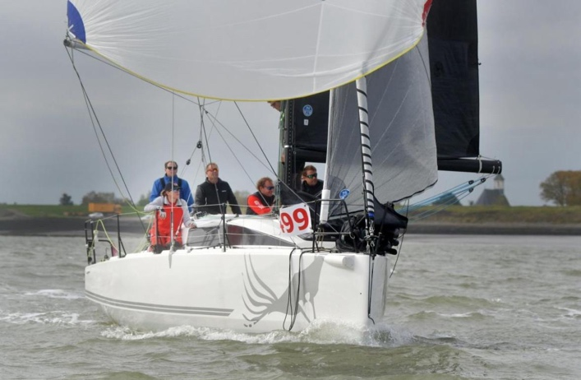Launched in 2020 in Corsica, *IL CORVO* is a JPK 10.30 now campaigned from Breskens in the Netherlands by Astrid de Vin and her co-skipper. Since taking ownership in 2023, the duo have focused on building a strong doublehanded partnership - one that will now be tested in the 2025 Rolex Fastnet Race.

Racing in the doublehanded division within IRC 3, their goals are refreshingly simple: “A great race, a wonderful experience, and a good result.” It’s a campaign that values focus, self-reliance, and the satisfaction of sharing every mile between just two people.

With minimal fanfare and quiet determination, *IL CORVO* represents the essence of Corinthian offshore sailing: lean, committed, and chasing the adventure that only a race like the Fastnet can offer.

**Social Media:**Facebook: Zeiljacht IL CORVO

**Dutch crew on Narwal return with eyes on a stronger result***Narwal, J/112E, Ubbo Neisingh*   
The Netherlands - IRC 3  
Yacht clubs: Marina Muiderzand, WSV Flevomare

Built in 2016 by J Composites, *Narwal* is a J/112E skippered by Ubbo Neisingh and crewed entirely by sailors from the Netherlands. After a strong debut in the 2023 Rolex Fastnet Race - where they finished 5th in IRC 2a - the team is back in 2025 aiming to climb the leaderboard and enjoy another offshore adventure.

“We’re hoping for slightly calmer weather this time,” says Neisingh, “but our main goal is to improve on last year’s result.” With a mix of students, IT professionals, and what they describe as “nothing special,” the crew focuses on teamwork over titles - with no fixed positions onboard and a fluid, adaptable approach to sailing.

Among the many things they’re looking forward to: the spectacular start out of the Solent, the emotional milestone of rounding Fastnet Rock, and the final run into Cherbourg with hundreds of boats around them.

The *Narwal* team brings a relaxed but committed spirit to the race - a blend of fun, focus, and a quiet determination to do better with every mile.

**Social Media:**Facebook: <https://www.facebook.com/NED9102>Instagram: <https://www.instagram.com/ned9102_narwal/>Video: <https://www.youtube.com/watch?v=GMugHE90ynQ>

**Contact:**Ubbo Neisingh - [ubbo@neisingh.nl](mailto:ubbo@neisingh.nl)  
**Olympix returns with fresh boat and IRC 1 ambitions***Olympix, Landmark 43, Alexander van der Torren  
Colijnsplaat,*   
The Netherlands - IRC 1  
Yatch clubs: RORC, Royal Rotterdam Yacht Club (De Maas), Yacht Club Noord-Beveland

*Olympix* is a Landmark 43 sailing under the Dutch flag with a strong racing pedigree and renewed ambition for 2025. Built in 2011 and acquired by current owner Hugo Gommers in 2024, this boat picks up where previous *Olympix*campaigns left off - continuing a Fastnet legacy that included entries in 2017 and 2019 aboard an X-Yachts X4.3.

For 2025, the team is aiming for the top: “We’re targeting a podium spot in IRC 1,” says crew member Alexander van der Torren. “And hopefully with a little less breeze than the previous two editions.”

The crew, yet to be fully confirmed, will include sailors from RORC, Royal Rotterdam Yacht Club (*De Maas*), and Yacht Club Noord-Beveland. Based in Colijnsplaat, they bring a seasoned, club-driven energy to the international fleet.

When it comes to the race itself, there’s one moment they’re particularly excited about: “Rounding the Rock - it’s always a special turning point. After the Irish Sea, it marks the shift downwind toward Cherbourg.”

With a refreshed platform and familiar team spirit, *Olympix* is looking to build on past experience and challenge for the front of the fleet.

**Social Media:**Instagram: @olympixned7084

**Dutch crew on Skeef returns for another all-in Fastnet ride***Skeef, Beneteau First 36.7, Eva Hermans*  
Hoorn, The Netherlands - IRC 3  
Yacht clubs: Yacht Club Hoorn

*Skeef* is a 2002 Beneteau First 36.7 with a few Fastnets under her keel and a crew that knows exactly what they’re getting into - and still loves every minute of it. Originally named *Carmen 2*, she was purchased in 2020 in Ardrossan, Scotland, by owners Peter Korver and Matthijs Hardeman, who sailed her back to the Netherlands and have been racing her with friends and family ever since.

Representing Yacht Club Hoorn, the team comes into the 2025 Rolex Fastnet Race without pressure, but with purpose. “We don’t expect to win,” says pit specialist Eva Hermans, “but we want to get the most out of the boat and the team.”

The crew thrives on pushing themselves hard. “As a team, we love to go deep - and then even a bit deeper,” says Hermans. “Because that’s when the beers after the finish taste the best.”

The full crew includes: Matthijs Hardeman - Helm & navigation, Peter Korver - Bow & navigation, Eva Hermans - Pit, Jeroen Korver - Mainsheet, Erik van Eden - Jib 1, Bas Verheul - Jib 2, and Abel Blaauw - Mast.

Professionally, they bring a mix of skillsets and energy: Matthijs is a Transavia pilot, Eva is a programme manager at the Dutch Central Bank (just finished the HQ renovation), Peter works in local government, and Bas is a general practitioner.

After competing in the 2019, 2021, and 2023 Fastnets, they’re hoping for “champagne sailing” - 15 knots, sunshine, and warm breezes. “But we guess it won’t be,” they admit with a laugh.

**Social Media:**Eva: [Facebook](https://www.facebook.com/share/1FXKVf7QE3/) | Instagram: @eva.j.hermans  
Matthijs: [Facebook](https://www.facebook.com/share/1DWzvfsYvd/) | Instagram: @matthijs.hardeman  
Peter: [Facebook](https://www.facebook.com/share/1FafWhkPf1/)

**NORWAY**

**Major milestone for Corinthian crew**

*Avanti II, JPK1030,* Kristian Kudsk Andreasen

Stavanger – IRC3

*Yacht Club: Gandsfjord Seilforening*

Kristian Kudsk Andreasen and Olai Haglandarea Corinthian doublehanded team entering the Rolex Fastnet Race for the first time, bringing with them passion for offshore sailing, deep experience from the North Sea, and a boat built for the challenge.

Avanti II is a JPK1030, hull #41, designed by Jacques Valer, and launched by JPK Composites in 2019. Kristian took delivery in January 2023 and immediately put her to the test—sailing non-stop from Lorient, France to Stavanger, Norway in March 2023.

Since then, the boat has been raced offshore in demanding North Sea conditions and the co-skippers are confident in her performance, safety, and capability to handle whatever the Fastnet course has in store.

Campaign goals: Their first objective will be making it to the starting line in race condition - a challenge in itself, involving a 650 NM offshore passage from Stavanger to Cowes. Once on the line, the aim is to deliver a solid performance in one of the most competitive fleets in offshore sailing: the IRC Doublehanded division.

“We’re not just racing—we’re testing ourselves against the best in one of the sport’s most iconic events,” says Kristian. “While we have experience in offshore races in the North Sea, the tidal currents and complex sea state of the Fastnet route will be new and exciting territory for us.

The race’s length, history, and strategic demands make it something very special. There will be multiple ‘races within the race’ — starting off with a potentially chaotic strategy might be the smart play. From there, rounding Fastnet Rock will be a defining moment, and the final stretch through the Channel—especially navigating the Alderney Race—will be about making the right strategic calls under pressure.”

The crew are Corinthian sailors, but take their campaign seriously:

**Kristian Kudsk Andreasen – Owner & Co-Skipper (NOR)**  
Kristian has a lifelong passion for sailing, starting in dinghies and moving into keelboats. He has raced out of Norway for the last 25 years, including six North Sea Races to Scotland. Over the last three years, he’s campaigned his JPK1030 in the Bergen–Shetland Race with strong results. He also competes locally in the Snipe class. Professionally, Kristian holds an MSc in Marine Engineering and works as a Project Manager for decommissioning offshore platforms in Norway.

**Olai Hagland – Co-Skipper (DEN)**  
Olai brings a wealth of experience from the dinghy world, having raced ILCA (Laser) at a high international level. He’s also competed successfully in the J/70 class and served as crew and boat captain on a Norwegian TP52. Technically skilled and resourceful, Olai holds an MSc in Subsea Engineering and works globally on complex subsea systems. Though only 25, he’s already a seasoned sailor with a mature, calm approach to offshore challenges.

“We teamed up as a double-handed crew in 2024 and see the Fastnet Race as a major milestone in our journey. Our JPK1030 is a robust and highly competitive offshore racer, designed by Jacques Valer and launched by JPK Composites in 2019. The boat is well-proven, both by the wider JPK fleet and through our own offshore racing in the North Sea. She gives us both performance and confidence when the conditions get rough—exactly what we need for a race like this.”

**Contact: Kristian Kudsk Andreasen -** [**kristian.andreasen@lyse.net**](mailto:kristian.andreasen@lyse.net)

**Kristian Kudsk Andreasen, KKAND@equinor, mob +4747711314**

**Third time lucky for Norwegian father-daughter team aboard LUPI***LUPI, Hallberg-Rassy 43, Louisa Børresen Bærum,* Norway - Double Handed  
Yacht clubs: Bærum Seilforening

*LUPI* is a Hallberg-Rassy 43 built in 2005, and while she may look more cruiser than racer, don’t be fooled. With proper sails, seamanship, and a determined crew, she has spent the past decade punching well above her weight in offshore races in and out of Norway. Skippered by father-daughter duo Bjørn and Louisa Børresen, *LUPI* will finally make her Rolex Fastnet Race debut in 2025 - after two missed attempts.

“Third time lucky,” says Louisa. *LUPI* qualified for the 2021 Fastnet but was sidelined by Covid. In 2023, they made it all the way to Cowes only for illness to force a DNS. Now, in 2025, *LUPI* is prepped, eager, and ready to add a distinct sight to the Solent - with her sturdy pilot house and unmistakable Hallberg-Rassy lines.

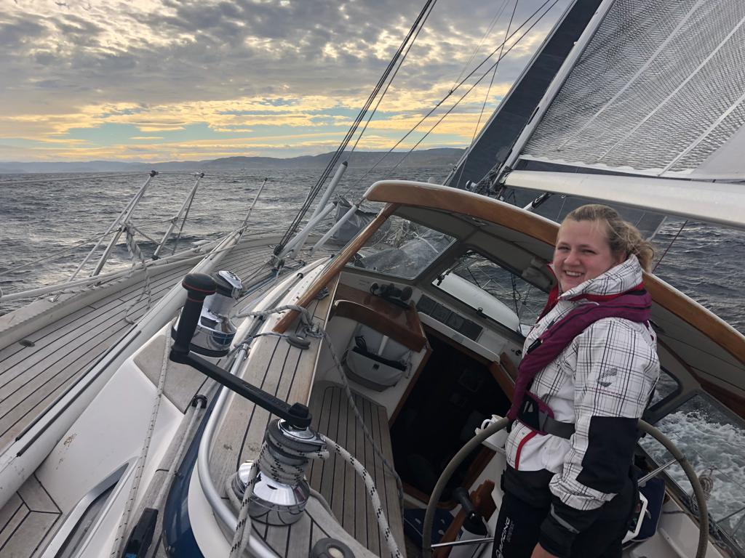The family history behind *LUPI* runs deep. This is the fifth boat to carry the name - the first was a Nolin 34 where the Børresen children first learned to sail. “We were often known as ‘the children’s boat,’” recalls Louisa. Since 2014, this *LUPI* has become a platform not only for adventure but for competitive sailing, as the pair have raced doublehanded together since 2017.

The Fastnet Race has long been on their bucket list, and the aim this year is simple: to take part, to push themselves and the boat, and to enjoy every moment. “Just participating and having fun competing together after so many years of preparation is as much of a win for us as any medal,” Louisa says. From the start line in Cowes to the thrill of rounding the Rock and the final celebration in Cherbourg, it’s all part of the dream.

Louisa will helm the start, take charge of the spinnaker, and sail hard despite recovering from a broken leg. Bjørn, a retired engineer from the oil and offshore industry - now a self-proclaimed “freak sailor” - handles navigation and everything else.

**Social Media:**Follow Louisa on Instagram: [@louloumartinez123](https://www.instagram.com/louloumartinez123/)  
  
**Norwegian team takes on Fastnet aboard ex-Kjus racer Turangalila***Turangalila, Grand Soleil 40R, Helge Midtgård*   
Sandefjord, Norway - IRC 1  
Yacht clubs: Sandefjord Seilforening

Originally commissioned in 2001 by former World Cup alpine ski racer Lasse Kjus, *Turangalila* began life with a pedigree crew and a string of Scandinavian race appearances. Since then, she’s transitioned into a dual-purpose family boat, blending cruising comfort with race capability - and for 2025, she’s back in full offshore mode.

Representing Sandefjord Seilforening, the current team is young, ambitious, and ready for a serious challenge. “I expect a tough race that will put a huge test on the crew’s ability to perform and endure,” says tactician Helge Midtgård. “Hopefully we will have a good race with a lot of experience gained. The aim is to finish in the top half of the scoreboard.”

The crew includes: Helge Midtgård (Norway, Sandefjord) - Tactician, Viggo Holm (Norway, Sandefjord) - Helm, Jacob Andreassen (Norway, Tønsberg) - Main trimmer, Sindre Angell-Hansen (Norway, Sandefjord) - Headsail trimmer, Ferdinand Juell-Bergan (Norway, Oslo) - Pit, Razley Ryklief (South Africa, Sandefjord) - Mast, andIver Elias Holm (Norway, Sandefjord) - Foredeck.

They bring a wide skill set to the boat, including one commercial pilot, one Royal Norwegian Navy officer, one carpenter, and four students - all combining to form a well-rounded, hands-on campaign.

Asked what they’re looking forward to most, the answer is simple: “The whole experience. And to complete the event together with the crew.”

**Social Media:**Instagram: [@turangalilayouthracing](https://www.instagram.com/turangalilayouthracing/profilecard/?igsh=cnZubHk4d2sxYjU5)

**SPAIN**

**Return with Veteran Corinthian Crew**

*MYLLA, Xp 38, Javier Sánchez Lamelas – IRC2*

Santander

Yacht Club: Real Club Marítimo de Santander – RCMS

Launched in 2014 and sold to her previous owner in Roscoff, Javier bought MYLLA back in 2020. After upgrades to sails, safety equipment, rigging and electronics, she has been successfully racing in the North of Spain.

Owner and helm, Sánchez Lamela completed the Rolex Fastnet Race in 2023, recalling one unforgettable moment: *“*We were sailing downwind near Scilly Isles, with a Jib 2 and one reef in the main. We were surfing and the Xp38 reached 24,7 knots (still recorded in the B&G). It was wild and completely unthinkable for a boat of that size and shape.”

This year, Javier will lead a Corinthian team, composed largely of good friends drawn from two rival J80 crews in Santander. “We all know each other fairly well and like sailing together. Interestingly, our average age in the boat should be around 55 years – I’m 62 and probably the oldest, while the youngest crew member is well over 40. We’ve got a mix of engineers, architects, an economist… and even a lawyer (God forbid!).”

Reflecting on the notorious 2023 edition, Sánchez Lamelas remains grounded: “The weather and sea conditions seem not to have a limit... it seems it always can get worst.*”* This edition, he is hoping for “better weather conditions than the wild 2023 race quite frankly. To sail safely, have fun, finish the race, reach a good position in our class, get back to Spain... in that order.”

**Contact: Javier Sánchez Lamelas - javier@marketingbeliefs.com**

**SWEDEN**

**Now you C-me…now you don’t…**

*C-me, First 40 CR Bruce Farr, Håkan Grönvall*

Svinninge Marina – IRC2

Yacht Club: RORC / KSSS

C-me is a thoroughbred offshore racer, built in 2009 and launched for the first time in 2010. Constructed in traditional fiberglass with a carbon fiber rig and a T-keel featuring a lead bulb, she's a proven performer. Since her debut, she has three Fastnet Races without a hitch. This year's race will be her fourth, an occasion made even more special by the 100th anniversary.

*Håkan Grönvall* (Stocksund), bought C-me in 2018 from Germany, where she had been indoors for 5 years, so she has really only been sailed for 8 seasons.

Håkan comments: “Her strong point is a strong headwind, but she has a bit of a hard time asserting herself against the new planing boats on the downwind.”

Goals for this year:

* That, with a little luck, they get less wind and better weather, especially during the early stages heading down to Land's End.
* That the crew succeeds in their goal, and that there is a good atmosphere onboard.
* Being able to master the unique challenges of the Fastnet—especially navigating tides and currents, which are quite foreign to Swedes, who are used to virtually tide-free sailing.
* Embracing the race’s reputation as one of the most demanding offshore events in the world.

Håkan’s interest in sailing started because his father built a sailing dinghy for him and his brother when he was 8 years old. Since then, he has had a number of boats, ranging from dinghies, archipelago cruisers (scarry cruiser) and seagoing boats. He has sailed the Gotland Runt many times (about 35), Middle Sea Race, Geraglia Cup, European ORC, Baltic 600 and, of course, the Rolex Fastnet Race.

The crew is a close-knit group of "old" friends - some have been racing together for decades, on Håkan’s boats and theirs, both in Sweden and internationally. They are from all walks of life, from military professionals to opticians: Håkan Grönvall, Stockholm, Skipper, Olof Granander, Stockholm, Nav/routing, Katarina Granander, Stockholm, Foredeck, Karin Lindquist, Stockholm, Pit, Per Tengå, Stockholm, Co-skipper, Niclas Heurlin, Stockholm, Nav /routing, Anian Kriege, Stockholm, Foredeck/trim, Magnus Silen, Helsinki, Helm, and Ingmar Ravudd, Stockholm, Trim/routing.

**Facebook: C-me race team**

**Contact: Håkan Grönvall - hakan.gronvall@gmail.com**

**SWITZERLAND**

**Lake Constance Classic Crusaders return to Fastnet**

*Crusade, GURNEY 64 Custom Classic Sailing Yacht, Daniel Heine - IRC2*

*Gstaad*

Yacht Club: Gstaad Yacht Club

Commissioned by the newspaper baron Sir Max Aitken, Crusade was designed by Alan Gurney and built in cold-moulded wood, in 1969, at Souters’ yard in Cowes on the Isle of Wight.  She was immediately shipped out to Australia where she won line honours in the 1969 Sydney Hobart Yacht Race. On returning to the UK, she was a renowned Admiral’s Cup racer.

The last time Crusade competed in the Fastnet Race was in 1969, when many thought she should have won the race – only to lose out to a timing error. More than half a century later, she’s now back, representing Gstaad Yacht Club, with a team from the Swiss mountains – an unlikely place to find ocean racers.

Many of them grew up sailing dinghies on Lake Constance and now compete on classic yachts across the Mediterranean, mostly in the 8 Metre class. Among them is pitman Reinhard Brucker, a seasoned sailor with an impressive nine world championship titles.

Daniel Heine,a RORC member and sailing officer of the Gstaad Yacht Club who is more used to sailing remote controlled model boats in the Gstaad indoor swimming pool, will be co-skippering with Nick Hayward-Young. He

shares the story:

“We all share the love for ocean racing, and I have already done most of the big ocean races, except the Fastnet. The last time we were in Cowes was after the 2011 Transatlantic race from Newport to the Lizard, when some of us sailed on Nordwind, a 1939 Henry Gruber Yawl.

Given 2025 is the centenary Fastnet, we wanted to finally sail this iconic race, and, of course, it had to be aboard a ‘classic’. With the help of Lucy Jackson, whom we have known for many years, and who has supported us so well on other races, we had the chance to charter Crusade, a yacht which immediately felt perfect to us – we are the same generation.”

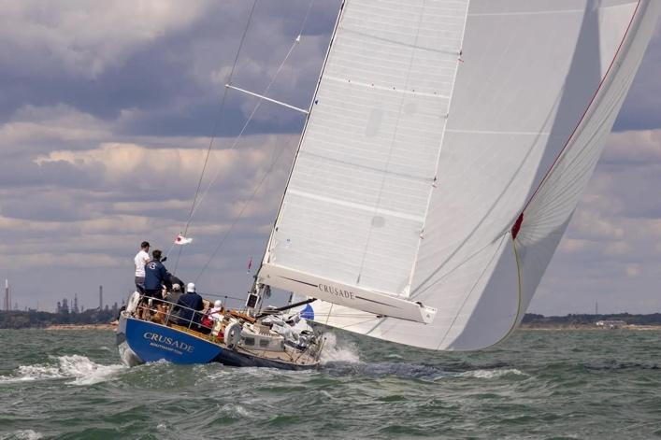

While matching Crusade’s second place finish in 1969 may be a tall order, the team is determined to do well against the other classics, and bring her safely back to shore. Lending his expertise is fellow Gstaad Yacht Club member and friend, Simon Koster, co-skipper of the Imoca 60 Hublot who finished second in the 2021 Transat Jacques Vabre and holds the record for the Tour of the British Isles 2020. As co-founder of the Swiss Offshore Team, Koster brings world-class offshore experience to the table as the team’s navigator.

**https://classicsailingyachtcrusade.co.uk**

**Contact: Abi Orton -** [**abi@lvyachting.com**](mailto:abi@lvyachting.com)

**2023 Fastnet Race winner returns**

*Caro, Botin IRC 52, Maximilian Klink – Admiral’s Cup 1*

Lucern, Switzerland

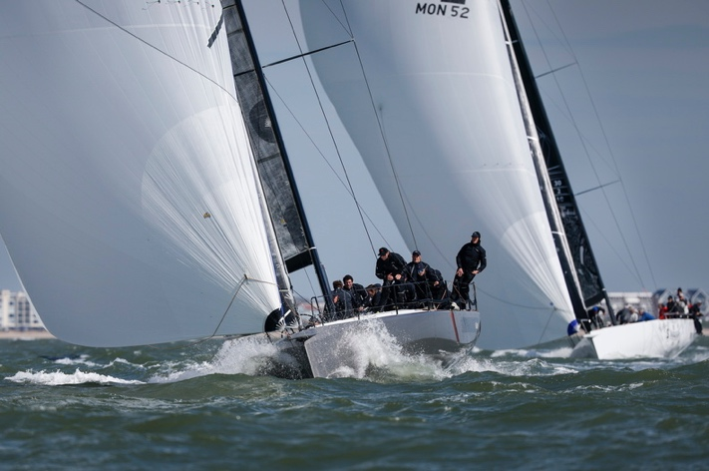The winners of the Fastnet Challenge Cup in the 2023 Rolex Fastnet Race will be back to defend their title. The team are competing in the Admiral’s Cup for the Royal New Zealand Yacht Club. “This will be a tough year with a race within a race,” says trimmer, Justin Ferris. “We always start a race with expectations of giving ourselves a chance to win. With the reinvention of the Admiral’s Cup, we are very much looking forward to competing in the iconic Rolex Fastnet Race event. The history and drama of these races make it so special, plus sunrise at the Fastnet Rock and turning the corner and heading for the finish line will be memorable moments.”

“Caro's team has been sailing together for many years and crew come from all corners of the globe, including two local (UK) boys Jules Salter and Adrian Stead,” continues Ferris.

**TURKEY**

**First All-Turkish Team in the Rolex Fastnet**

*F35 Express, Beneteau First 35, Yiğit Eroğlu (Skipper) – IRC4*

Cowes/Bodrum, Turkey

Yacht Club: Hedef Yelken Club (a Turkish sailing club and sailing school)

For the first time ever in the history of the Rolex Fastnet Race, an all-Turkish sailing crew will compete, sailing under the TUR sail number.

This is more than just a race entry — it’s a defining moment for Turkish sailing on the international stage. For this team, it marks the realization of a long-held dream. Sailing, not merely as a sport, but as a way of life, they embark on this legendary course driven by the desire to represent not only themselves, but every sea-loving soul in Turkey.

Skipper Yiğit Eroğlu shares: “It is a great honour and responsibility for us to participate in the 100th edition of the Fastnet Race, with a team made up entirely of Turkish sailors. We’ve dreamed of this race for years, and now, on its centennial, we will proudly raise the Turkish flag on this historic course. The Rolex Fastnet is not just a race — it’s a true test of character, perseverance, and belief. Through this experience, we hope to inspire young sailors in Turkey to believe in what’s possible. We want this to open the door for more Turkish teams to step onto the international sailing scene.”

Yiğit continues: “My passion for sailing began in childhood and has since become both my profession and my way of life. My wife is a yacht designer, and our twin sons, now five years old, are already sailing Optimists. For our family, sailing is not just a hobby — it’s a lifestyle. Whether we’re racing, cruising, or delivering a boat, being at sea in any form is simply essential to us.”

My deeper journey into offshore sailing began when I came to Hamble as a university student. I spent two full months training at British Offshore Sailing, gaining hands-on experience, not just in offshore sailing, but also in how a sailing school operates.

I took that knowledge back to Turkey and successfully opened my own sailing school, Hedef Yelken Club, which has grown to become one of the most prominent in the country, where we’ve trained thousands of sailors and organized the biggest major regatta.”

The eight-person crew, composed of experienced sailors from diverse professional backgrounds, has spent years balancing offshore sailing with their careers. The team came together on a fully voluntary basis and has remained entirely self-funded throughout their journey — driven by passion, dedication, and the pride of representing Turkey in one of the world’s most revered offshore races.

Yiğit brought his Beneteau First 35 (2012) boat from Turkey to the Solent in 2017, and started racing— taking part in the Round the Island Race almost every year since. For the last five years, the boat has been based in Cowes, and has a UK flag, but the sail number is TUR.

As they take to the waters in this centennial edition of the Rolex Fastnet Race, they carry with them not just the wind in their sails, but the hopes of a growing sailing nation.

**Contact:** **Dilek Özcan, +90 533 374 88 08, dilek.ozcan1983@gmail.com**

**USA**

**Pyewacket’s first Fastnet campaign**

*Pyewacket, Volvo70, Roy Disney - IRCSZ*

San Diego, California

Yacht Clubs: San Diego YC, New York YC

Roy Disney's Pyewacket70 team features a well prepared turbo'd Volvo70 (ex-Black Jack/ex Telefonica (Volvo 2011-12)), sailed by an international crew of professional sailors.

Hailing from San Diego, California, this will be Pyewacket70's first Fastnet Race, though Roy and the crew have all enjoyed this classic ocean race on other boats many times and are looking forward to a fun race.

Over the past four years, Roy and team have campaigned this boat in the Pacific, Atlantic, Mediterranean and Caribbean to great success.

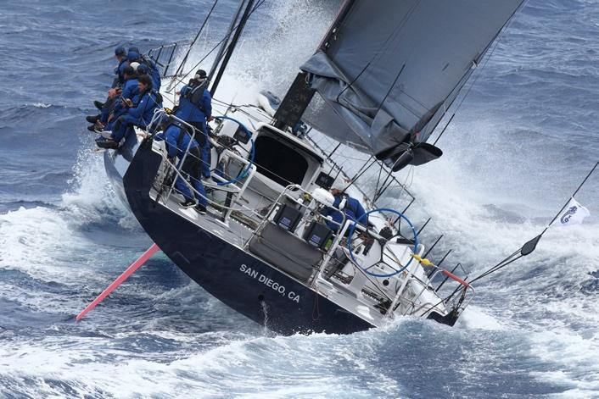

Roy is continuing in the tradition that his father (Roy E. Disney) started in the 70's - first racing a series of "Pyewacket"-named "sleds" on the west coast of the US, before expanding the team's horizons and becoming one of the most well-known and respected programs on the international grand prix circuit for many years.

Most challenging will be: “keeping the keel on the boat - my last one ended differently.”

**Contact: peter.isler@yahoo.com** [**www.islersailing.com**](http://www.islersailing.com)

**Old sea dog defies time and the elements**

*Hound, Aage Nielsen-designed aluminium sloop*, *Dan Litchfield – IRC 1*

Newport, RI, USA

Hound is a 59-foot aluminium sloop designed by Aage Nielsen and built by Abeking & Rasmussen in 1970. For more than 50 years, she has been a familiar sight on the ocean racing circuit, known for her graceful lines and enduring spirit.

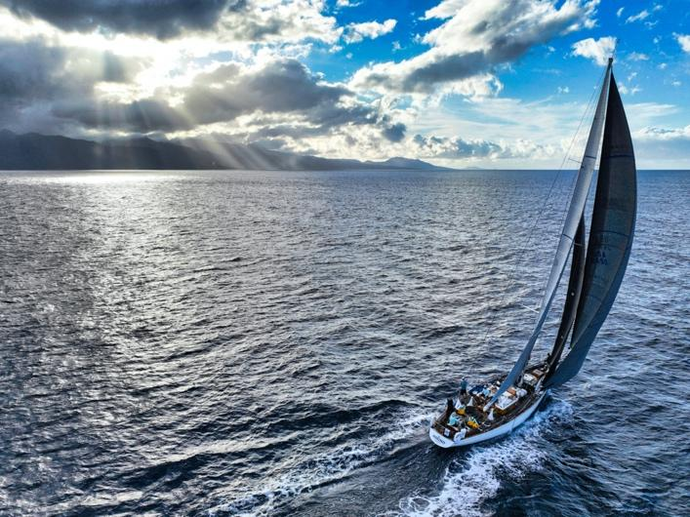

Owned by Dan Litchfield, and captained by Tom Stark since 2020, Hound has undergone a careful refit and found new success on the racecourse—proving that classic design and modern performance can still make a winning combination.

As *Newport Buzz* put it in their 2024 profile [*Hound: An Ocean Racing Legend*](https://www.thenewportbuzz.com/hound-an-ocean-racing-legend-set-to-tackle-the-transatlantic-race-2025/50319):

“In the world of ocean racing, some boats wear their miles with the rugged charm of seasoned sailors, while others, like Dan Litchfield’s *Hound*, defy time and the elements. Launched over 50 years ago, this Aage Nielsen-designed 59-foot sloop continues to prove her mettle against much younger and more technologically advanced competitors.”

Under Litchfield’s stewardship, *Hound* has earned a string of top finishes:

* **2nd place overall**, Saint David’s Lighthouse Division, *2024 Newport Bermuda Race*
* **3rd place**, IRC Class One, *2024 RORC Caribbean 600*
* **1st place**, IRC Class One, *2023 RORC Caribbean 600*
* **1st place, ORR Class Five**, *2022 Newport Bermuda Race*

An extensive refit, including the installation of a taller carbon fiber mast, has helped Hound stay competitive at the highest levels.

Her legacy continues to grow. Award-winning author and Olympic sailor [Carol Newman Cronin](https://carolnewmancronin.com/about-carol/) is currently writing a book about her titled: "The Heart of Hound: Half a Century of Sailing, Camaraderie, and Stewardship." Hound is also one of ten featured yachts in the upcoming “Drive-to-Survive”-style documentary series *Windblown*, directed by acclaimed documentarian Benjamin Ringe, about the 2024 Newport Bermuda Race.

Team Hound has raced together since 2022, logging thousands of ocean miles side by side. Most of the crew for the 2025 Fastnet Race will be fresh off completing the Transatlantic Race in June.

For many onboard, the Fastnet has long been a dream and the top race left on their bucket lists. But Hound’s Fastnet roster blends these passionate first-timers with seasoned veterans, including Conrad Humphreys (Navigator), Richard du Moulin, Chris Huntington and Lyndsey Gibbons-Neff.

**Contact: Nicholas Horbaczewski -** [**nhh100@gmail.com**](mailto:nhh100@gmail.com)

**Fifth time for Jason and the Argonauts**

*Argo, MOD70, Jason Carroll*

New York

Yacht Club: Larchmont Yacht Club

Jason Carroll’s MOD70 *Argo* is no stranger to setting records—or turning heads. Since entering the scene under Carroll’s leadership as Argo in 2019, she has blazed a trail across the offshore multihull racing world, boasting eight outright race records and three world records, including a multihull course record for the Newport Bermuda Race and an Antigua to Newport record. This will be her fifth Fastnet campaign.

Carroll himself is a two-time Melges 32 World Champion, but he remains the only amateur aboard an otherwise all-professional line-up. The Argo crew is a seasoned and cohesive unit of multihull veterans, featuring some of the sport’s biggest offshore names: Brian Thompson (Sailing Master) – Vendee Globe, Jules Verne Trophy, Chad Corning (Navigator), Peter Cumming – Volvo Ocean Race veteran, Westy Barlow, Chris Maxted, and Charlie Ogletree – all key players in *Argo’s* continued success.

Argo is aiming for both line honours and a strong corrected-time finish under the MOCRA handicap, with a keen eye on outpacing their sistership, MOD Zoulou.

The crew relishes every tactical and scenic stage of the Fastnet course—from the adrenaline of blasting out of the Solent, to the dramatic approach to Fastnet Rock if caught in daylight, to the tidal complexities along the French coast before the final push to Cherbourg.

Why the Fastnet?"It's one of the classics," says Carroll. “The huge fleet, the atmosphere in Cowes and Cherbourg which are second to none, and the challenge of the ‘gates’—the Needles, Land’s End, the Scillies, Fastnet, and the long haul up the Channel—make it one of the most rewarding races out there.”

Success, as always, may come down to catching the tidal gates just right—an offshore sailor’s blend of strategy, skill, and luck.

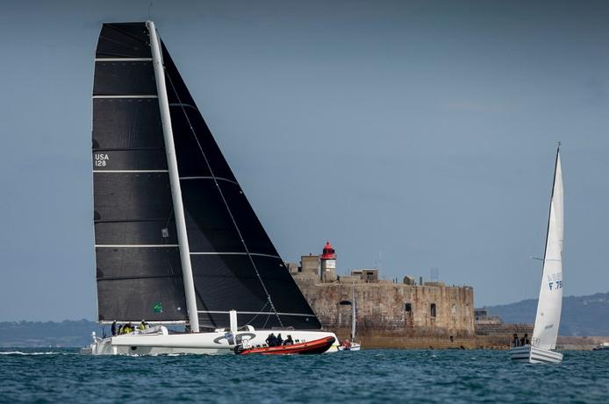

Jason Carroll - New York, NY, USA - Skipper

Brian Thompson - Winchester UK - Sailing Master

Chad Corning - Larchmont, NY, USA - Navigator

Peter Cumming - Poole, UK - Trimmer

Westy Barlow - Charlestown, RI, USA - Bow

Charlie Ogletree - Houston, TX, USA - Helmsman

Alister Richardson - Bournemouth, UK - Helmsman/Tactician

Chris Maxted - Portsmouth, RI, USA - Trimmer

[**https://www.facebook.com/Argo32Racing/**](https://www.facebook.com/Argo32Racing/)

**Contact: Chad Corning (navigator) -** [**charles.corning@gmail.com**](mailto:charles.corning@gmail.com) **- +1-914-714-3687**

**Vintage icon in Fastnet Fleet**

*Hiro Maru, Custom S&S 49, Hiroshi Nakajima*

Stamford, Connecticut USA – IRC3

Yacht Club: Stamford YC, RORC, CCA (Cruising Club of America), Storm Trysail Club, New York YC,

Royal Thames YC; New York YC.

Race number four in the Fastnet for owner/skipper Hiroshi Nakajima on Hiro Maru, a timeless 49-foot aluminium sloop designed by Sparkman & Stephens in the late 1960s, and launched in 1971 by Palmer Johnson in the USA. Originally named Scaramouche—sistership to Bay Bea and Aura—Hiro Maru carries a storied legacy, including a Class B win in the 1972 SORC, Class B win in the 1977 Transpac, and a class win and second overall in the 2019 West-East Transatlantic Race (IRC-3). Few boats can claim victories in both the Atlantic and Pacific oceans—42 years apart.

This marks the fourth Fastnet Race for Hiro Maru, and the team's goal is to be among the first vintage displacement yachts to finish in their class.

Skipper Hiroshi Nakajima began racing over 55 years ago in dinghies and keelboats. “I’ve been crewing in offshore distance races and campaigning my own 1969 Swan 43 and this 1971 Custom S&S 49 for decades. Sailing keeps you young,” he says.

The crew is entirely Corinthian, a close-knit group of friends. Half are members of the Royal Ocean Racing Club (RORC), and several also belong to the Cruising Club of America (CCA) and the Storm Trysail Club.

Crew includes: Mark D'Arcy (Tiburon, CA) – Navigator, Bob Langstine (Lawrenceville, GA) – Watch Captain, William Wiese (Duxbury, MA) – Watch Captain, Kyle Comerford (Annapolis, MD) – Foredeck Crew, Michael Millard (Riverside, CT) – Crew, Megan Gimple (Newport, RI) – Crew, Ryan Barnett (Oakland, CA) – Foredeck Crew, Yuko Nakajima (Stamford, CT / Japan) – Cook. A sailboat in the water

Three of the crew have sailed with Nakajima since 2018 and were aboard for the 2019 (West-East) Transatlantic Race, and 2019, 2021, and 2023 Fastnet Races, as well as the 2022 and 2024 Round Ireland Races. Another crew member previously raced in the 2019 Transatlantic and Fastnet aboard Carina, a direct competitor to Hiro Maru.

A fifth crew, a long-time friend, brings unmatched experience, including the 1975, 1979, and 2015 Fastnet Races, 1979 Transatlantic Race, and is a veteran of 16 Newport-Bermuda Races—many as a solo or double-handed entrant.

Also aboard is an accomplished young offshore woman sailor, 2021 Fastnet crew alumna and veteran of multiple Newport Bermuda Races, Marblehead-Halifax, and Annapolis-Newport. Another joins from the US West Coast, with Transpac race experience, deliveries and near shore one-design credentials. Rounding out the team is Nakajima’s spouse, Yuko, who serves as the cook and has sailed in the 2019 Fastnet, 2024 Round Ireland, and Newport Bermuda Races.

The team looks forward to “more warm sunny weather,” but they know the real challenge lies in navigating the complex tides and currents between The Needles and Plymouth. “Unlike the Newport Bermuda Race, the Fastnet offers a dynamic mix of offshore and nearshore conditions, with the added complexity of strong tides and shifting weather,” Nakajima notes.

For this US-based team, one of the great joys of the Fastnet is racing among the iconic landmarks of UK and Irish sailing lore: the Solent, Needles, Portland Bill, the Lizard, Isles of Scilly, Fastnet Rock, Cape Clear Island, and Cherbourg.

**Contact:**

**Hiroshi Nakajima - hiromaru43optonline@gmail.com**

**Navigator/onboard reporter: Mark D'Arcy - mark.darcy@nyu.edu**

**Fulfilling a childhood dream**

*Callisto, Botin Partners/GP 42, James Murray – Admiral’s Cup 2*

Roche Harbor, Washington

Representing the Royal New Zealand Yacht Club in the 2025 Admiral’s Cup: “I’m excited to be taking part in this epic event which has been atop of my “must do” race list since I was a kid sailing Lasers,” says James Murray of his first Fastnet Race. “It is an epic racetrack with incredible competition in any given year, but with the Admiral’s Cup it will be all the tougher. The race is very much a ‘George Leigh Mallory’ kind of thing. We do it because it’s there and it’s the Fastnet. Rounding the Fastnet Rock is something I’ve dreamt about for 40 years. Time to do it for real!”

Team Callisto is currently campaigning: J/70 (2024 US National Champs), J/125 (Section Winner, 2024 Chicago to Mackinac Race, our maiden outing on that boat), GP 42 (our Admiral’s Cup / Fastnet entry, winner of the NYYC Challenge Cup at Cowes Week in 2024) and Pac52 (our Sydney Hobart ride for 2025, will be my first Hobart Race).

The crew for the Admiral’s Cup and Rolex Fastnet Race has not been announced yet. “The skipper is the only Cat 1 aboard and the crew will include multiple America’s Cup, Volvo, and TP52 Super Series veterans. Callisto Racing is a pro-am effort, but the Admiral’s Cup is a departure from past practice. We are racing fully pro for this event and the warm-ups.”

Instagram: @callistoracing

**US owner racing in Admiral’s Cup***Final Final, Pac 52, Jon Desmond – Admiral’s Cup 1*

Final Final, the Pac 52 was built in 2017; previously Bad Pak and then Warrior Won. Russell Whitworth, crew member (pit) on Final Final says: “We are looking forward to the Rolex Fastnet Race and a strong finish to an exciting Admiral’s Cup. We are hoping for a slightly lighter start than the last couple of (Fastnet) races, making it more of a race than attrition, but we’ll be ready for whatever comes. What makes the race special is certainly the departure from Cowes, the exit from the Solent and the passage to the Channel Islands. The history, the size of the race, the Solent start, the Needles, the lighthouses - all of it make this such a grandstand race.”

What are the highlights of the Race? “Always the Rock (Fastnet), it’s such a visual impact to a sailor, so many historic images of yachts rounding that landmark over the years!” continues Whitworth who has competed in the race four times before.

“We have a great team, slowly built around a group of individuals sailing with the owner for many years, obviously with some additions for the Admirals’ Cup and the step-up we made to the Pac 52 in late summer 2024.

The team includes: Cameron Appleton (America’s Cup), Jim Turner (America’s Cup, Olympics), Nick Bice (Volvo Ocean Race), as well as several other great sailors making up this team’ the mileage count is high!

#finalfinalracing

Media contact: Sarah Desmond - [sarahvrlevis@gmail.com](mailto:sarahvrlevis@gmail.com)

**After 30,000 miles, Spirit 47 returns home for Fastnet debut***LUNA, Spirit Yachts C47, Alessandro Pagani*   
Marblehead, MA, USA - Double Handed

*LUNA* is a 2016 Spirit Yachts C47 - cold-moulded and built in Southampton - and for her co-owner and skipper Alessandro Pagani, this year’s Rolex Fastnet Race is more than a debut: it’s a return.

Having crossed over 30,000 nautical miles since her launch, *LUNA* will sail from Newport, Rhode Island to the UK ahead of the race. “Just making it to the start line is already a great goal,” says Pagani. “We’ll have to race across the Atlantic to get there first.”

Once in Cowes, *LUNA* will line up in the doublehanded division - an ambitious challenge made all the more meaningful by the boat’s history. “She was first launched in Southampton in 2016. I like the idea of bringing her home on her own bottom nine years and 30,000nm later,” Pagani adds.

It’s all new territory for the team - but that’s part of the excitement. From the transatlantic lead-up to the crowded Solent start, *LUNA*’s journey to the Fastnet.

PRESS CONTACT:

#RolexFastnetRace <http://www.rolexfastnetrace.com/>

**RORC PRESS OFFICER:**

Trish Jenkins - Press Officer - Rolex Fastnet Race  
M: +44 (0) 7880 518 689 (+ WhatsApp)

E: [press@rorc.org](mailto:press@rorc.org)